**Payment Instruction:**

Open the link - https://www.onlinesbi.sbi/sbicollect/

**Step - I**

Search by Institute Name / Organization Name (Enter Minimum 4 Characters) – DEPUTY COMPTROLLER CAU

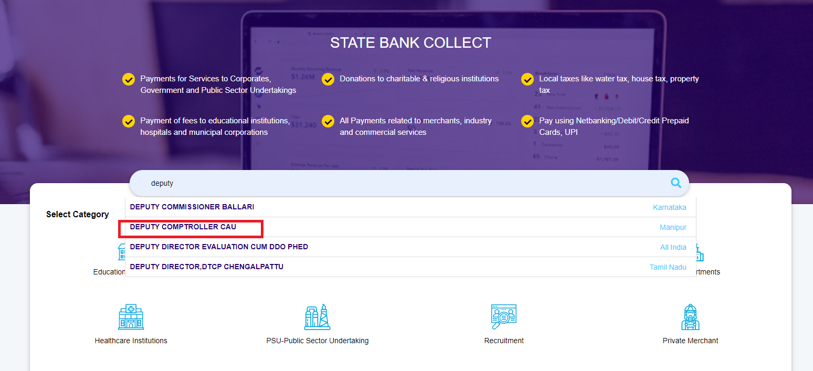

**Step – II**

Select Payment Category – **RECRUITMENT FEE**

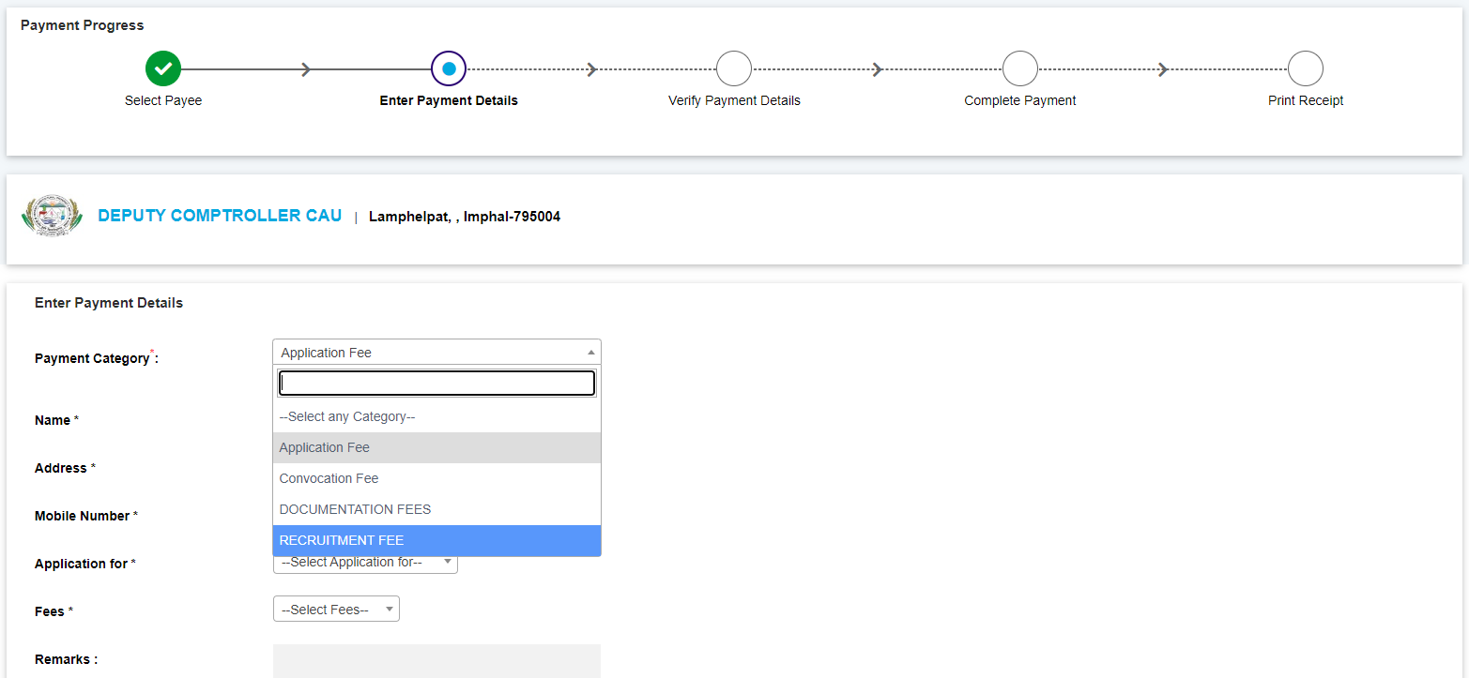

**Step – III**

Fill the details and make the payment