College of Fisheries Celebrates 24th National Fish Farmers’ Day
The College of Fisheries, CAU (Imphal) in association with the North East Society for Fisheries and Aquaculture (NESFA), India celebrated the 24th National Fish Farmers’ Day at the college campus on July 10, 2024, i.e., today. This crucial day is celebrated in India in commemoration of the revolutionary “Induced Breeding Technology” developed by Dr. Hiralal Choudhury and Dr. K. H. Alikhuni on July 10, 1957, which went on to change the face of Indian aquaculture. Welcoming the gathering, Prof. A. B. Patel, Dean of the college, Convener and Chairman, Organizing Committee of the programme highlighted the significant contributions of the farmers towards the development of the fisheries sector as well as the role of the College of Fisheries in helping and supporting them. He also acknowledged the support and guidance received from Dr. Anupam Mishra, Hon’ble Vice-Chancellor of CAU (Imphal). The programme was graced by Prof. Dr. Ph. Ranjit Sharma, Director of Extension Education, Directorate of Extension Education, CAU, Imphal, Shri Anil S. Kotmire, General Manager, National Bank for Agriculture and Rural Development (NABARD), Tripura, Prof. Ratan Kumar Saha, Hon’ble Vice-Chancellor, Techno India University Tripura, Dr. Burhan U. Choudhury, Principal Scientist and Head, ICAR-Regional Center, Tripura and Shri Jyotish Talukdar, Director, Kalong-Kapili (NGO), Guwahati Assam.

The Chief Guest of the programme, Dr. Ph. Ranjit Sharma, Director of Extension Education, CAU, Imphal graced the occasion and inaugurated the Exhibition cum Technology Showcasing. He applauded the college staff and students for their collective initiative. Dr. Sharma in his keynote address emphasized the importance of the day and mentioned the key initiatives of the CAU, Imphal towards sustainable fishery development in the region. Progressive fish farmers, namely Mr. Rockson Kashung (Manipur), Mr. Khalainbor Pale (Meghalaya), Ms. Yeamoty Pigyor (Arunachal Pradesh), Mr. Da Norbu Sherpa (Sikkim), Mr. Ramdi Thou (Nagaland), Mr. Jaydev Sarkar (Assam), Mr. LALHMUNSANGA (Mizoram), and Mr. Sujit Das (Tripura) were awarded by the Chief Guest and other dignitaries for their remarkable entrepreneurship contribution to different avenues of fisheries and aquaculture viz. Seed production, rearing, grow-out etc. The guests of the event distributed fish seeds and other technology products to the fish farmers of Tripura under this programme. The programme was jointly sponsored by NABARD, SBI, NFDB, ONGC, TECHNOPREZ etc. Around two hundred (200) fish farmers joined the programme, and they interacted with the experts. The event was telecasted live on the social media pages through the Public Relation and Media Management Cell of this college. A Farmers-Scientists Workshop was also held on “Blue Transformation in North East India: Farmers’ Perspectives” witnessing wide participation from different sections. The programme ended with a vote of thanks by Prof. Anil Datt Upadhyay, Dept of FEES.

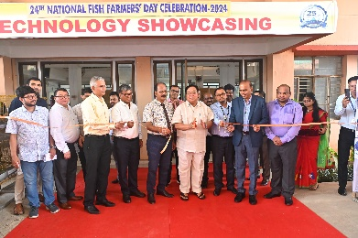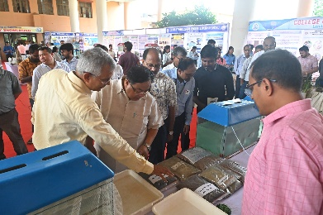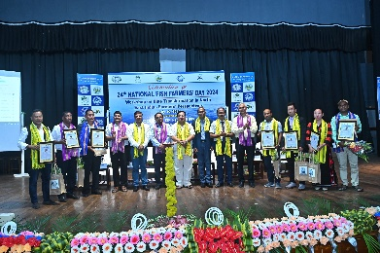

Lembucherra, the 10th July, 2024

(Prof. Prof. A. B. Patel)
Dean, COF-CAU

