Payment Guidelines
Follow the steps below

Step –I
Go to https://www.onlinesbi.sbi/sbicollect/
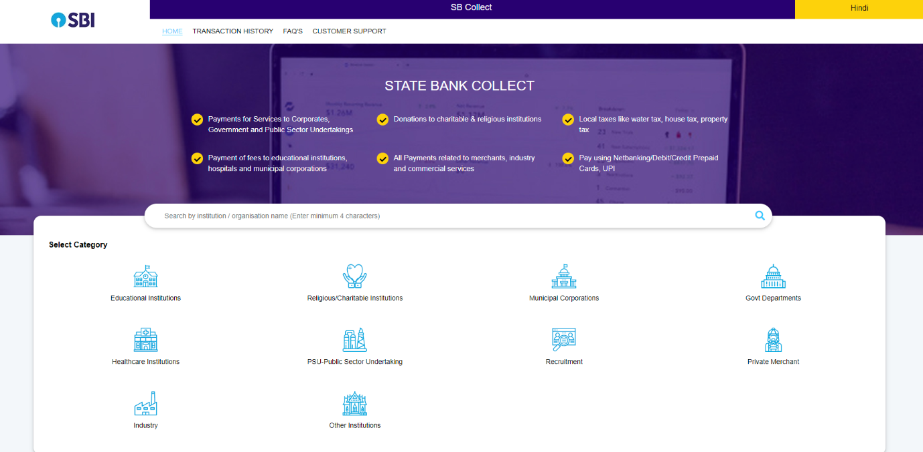

Step – II
Type Deputy Comptroller CAU
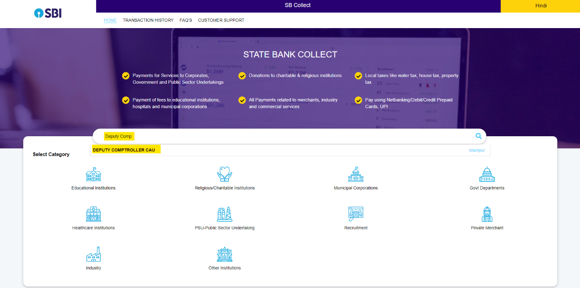

Step – III
Select Payment Category – Recruitment Fee
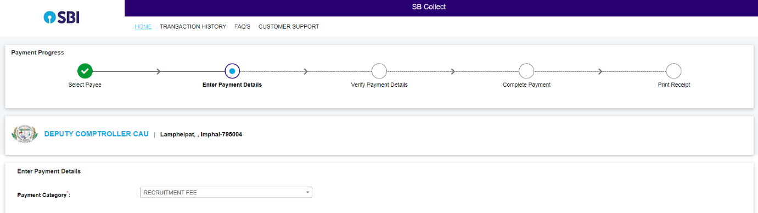

Step – IV
Select Name of the POST – Non-Teaching
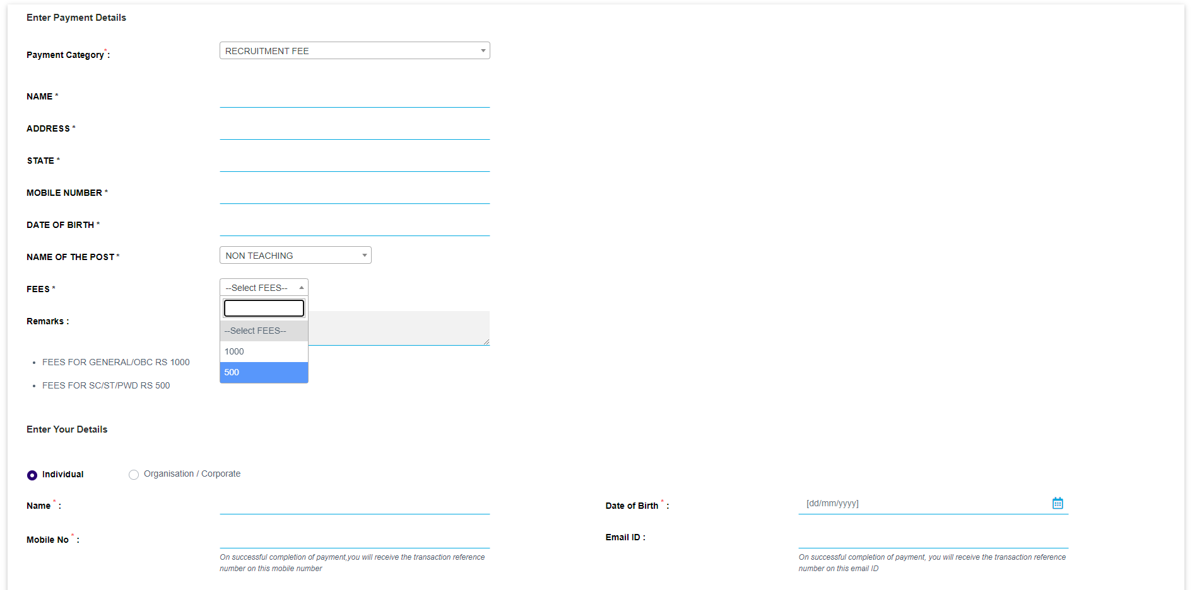
Step – V
Fill the details and complete payment using Debit Card/Credit Card/Net Banking/UPI

