Weekly activities of the IDP- NAHEP under Central Agricultural University, Imphal
(17th June to 23rd June, 2022)

- Two-days invited lectures by leading aquapreneur Dr. Atul Kumar Jain, Director, Ornamental Fisheries Training and Research Institute, Udaipur, Rajasthan was conducted at College of Fisheries, Lembucherra, Agartala on 23rd June, 2022. A total of 106 students attended the lecture.

SOCIAL SAFEGUARDs/Gender Equity Chart
SL No | Activities |  | Target | Achieved | ST |  | SC |  | OBC |  | GEN |  | TOTAL
A. Capacity Building for Students
01. | Invited lectures on the topic pertaining to “Entrepreneurship Development in Ornamental Fish Culture” | B.F.Sc. 2nd , 3rd, and 4th year students of the college |  | 106 | F | M | F | M | F | M | F | M | 106
 |  |  |  |  | 24 | 33 | 3 | 4 | 12 | 14 | 9 | 8

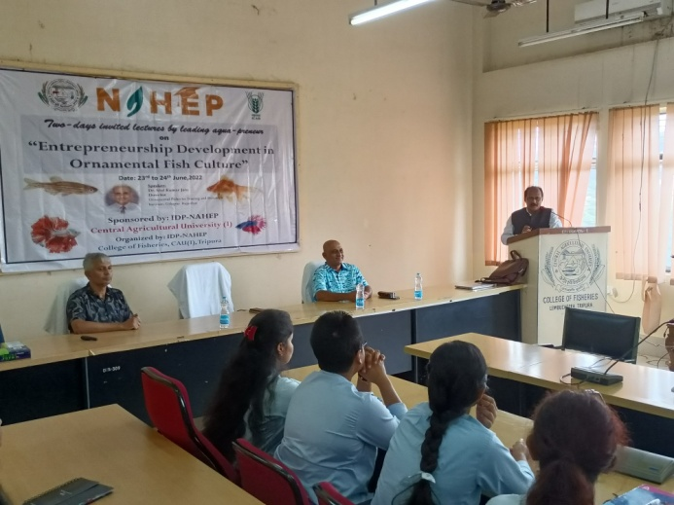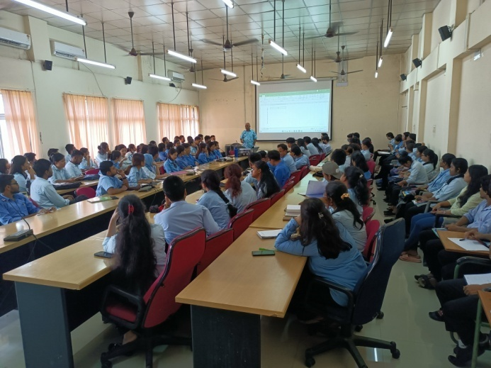
Photo: Inauguration and first lecture of invited lectures series on Entrepreneurship development in ornamental fish culture

- College of Veterinary Science & AH, Aizawl conducted language classes on 16, 20 and 21 June 2022. A total of 37 students took part I the said class. The class was conducted by language instructor of IDP, NAHEP.
SOCIAL SAFEGUARD
Sl no | Activities | Target | Achieved | ST |  | SC |  | GEN |  | OBC |  | Others |  | TOTAL
 |  |  |  | M | F | M | F | M | F | M | F | M | F
A |  |  | B. Capacity Building for students
1 | Language Class | 4th year BVSc Group A | 16.06.22 : Language Class | 1 | 7 | 0 | 0 | 1 | 0 | 2 | 1 | 0 | 0 | 12
2 | Language Class | 4th year BVSc Group B | 16.06.22 : Language Class | 0 | 1 | 0 | 0 | 0 | 0 | 1 | 0 | 0 | 0 | 2
3 | Language Class | 1st year MVSc | 20.06.22 : Language Class | 1 | 8 | 0 | 1 | 0 | 0 | 0 | 3 | 0 | 0 | 12
4 | Language Class | 2nd year MVSc | 21.06.22 : Language Class | 0 | 3 | 2 | 0 | 1 | 1 | 0 | 0 | 0 | 0 | 7
5 | Language Class | PhD Scholars | 22.06.22 : Language Class | 0 | 4 | 0 | 0 | 0 | 0 | 0 |  | 0 | 0 | 4
 |  |  |  | Grand Total |  |  |  |  |  |  |  |  |  | 37

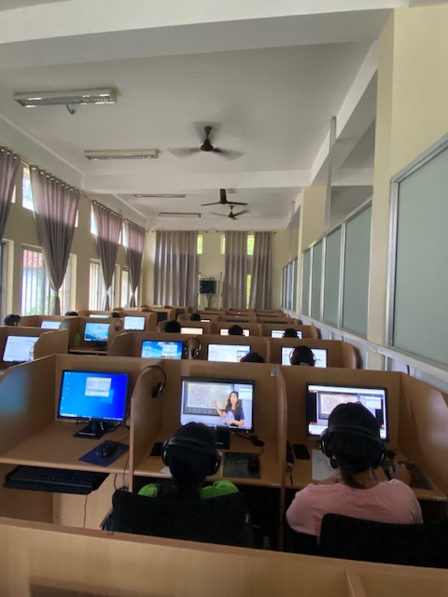
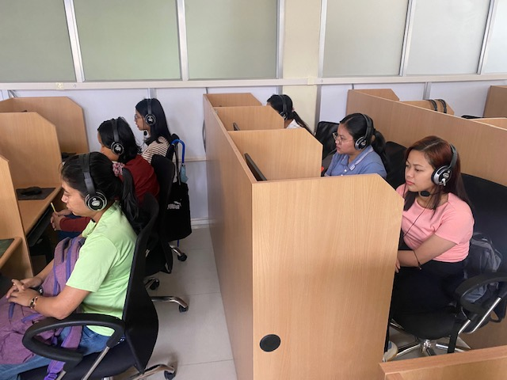

Photo: Students during the language class, CVSc & AH, Aizawl

Social Safeguard
(7 days Workshop on Communication Skill, Soft Skills, Personality Development and Stress Management)
Sl no | Details | Achieved | ST |  |  | SC |  |  | GEN |  |  | OBC
 |  |  | F | M | T | F | M | T | F | M | T | F | M | T
1 | Public speaking(Group B students) | 35 | 13 | 9 | 23 | 1 | - | 1 | 2 | - | 2 | 5 | 6 | 11
F = Female, M = Male, and T = Total
- On June 18th, 2022, the 7-day workshop on communication skills, soft skills, personality development, and stress management, which is held every Saturday, resumed with the topic "Public speaking" at College of Agriculture, Iroishemba. The speaker of the topic was Patricia Buhril, Corporate Trainer, Overseas Point, for Group B students. The workshop drew a total of 35 third-year B.Sc. students from Group B.
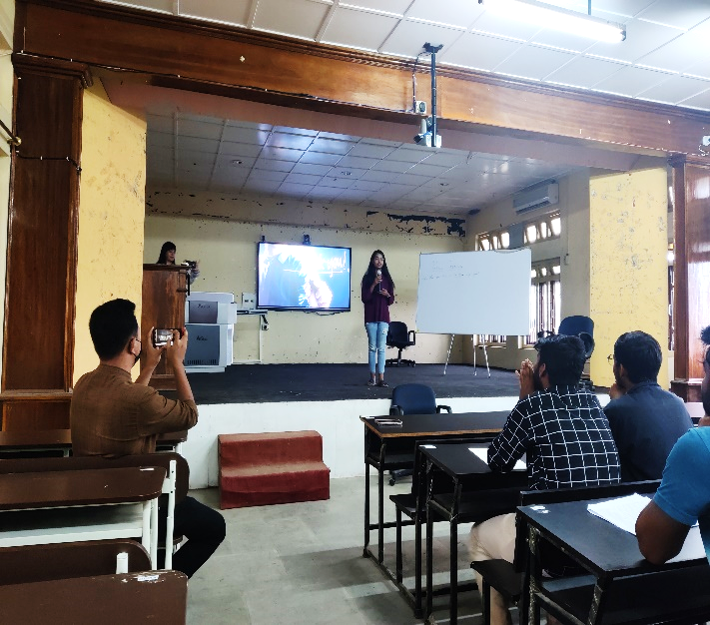
- College of Community Science, Tura conducted Communication Skills and Personality Development (BSH-249) on 16 and 22 June 2022 by the language instructor.
Batch | Date | Topics discussed | Total No. of Students present in the class | Attendance % | Study material/ assignments/ practical provided through WhatsApp and email
ND & CS 1st Year | 16.6.2022 | Quiz | 50 | 90 | -
ND & CS 1st Year | 22.6.2022 | Various orders to develop a paragraph: cause-effect, problem-solution | 51 | 92 | Links, PPT
Photo 1: 7 days’ Workshop on Communication Skill, Soft Skills, Personality Development and Stress Management on the topics “Public Speaking” held on 18th June 2022 (Group B, B.Sc. 3rd year students)

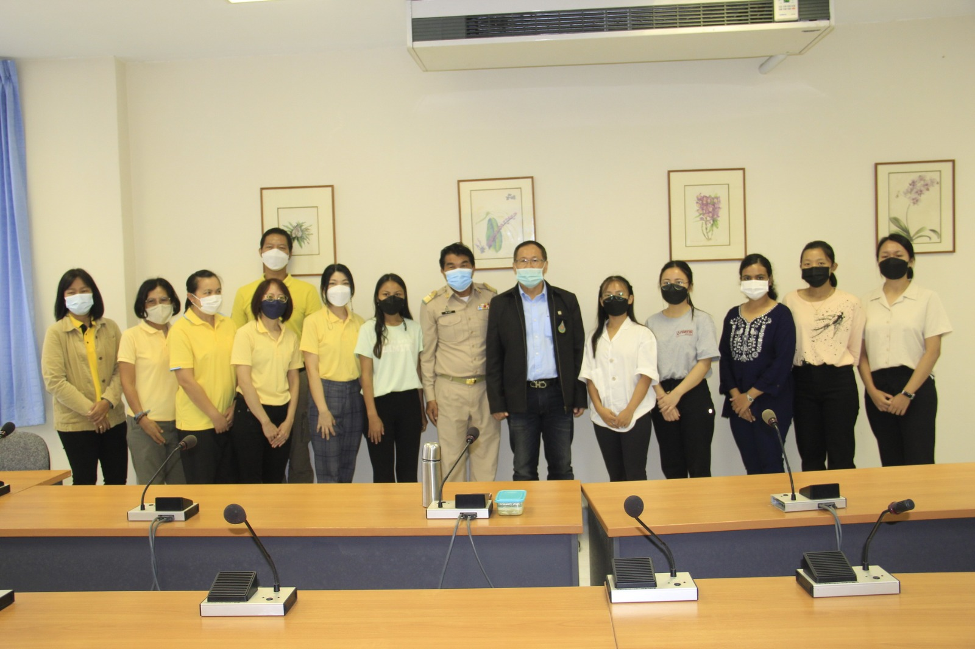
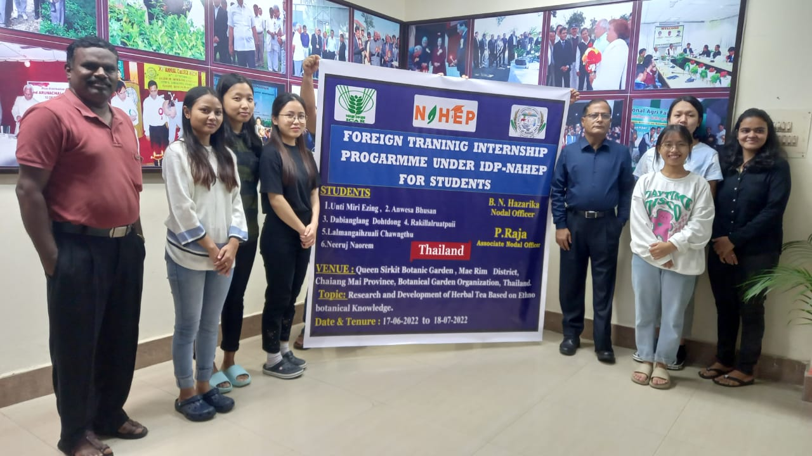
- 7 B.Sc.Horticulture students of College of Horticulture and Forestry, Pasighat departed for the Foreign Training at Botanic garden Organisation, Malaysia on 17th June 2022. They have started their internship immediately on reaching the host institute.
Photo: Students departing for the Botanic garden Organisation

Photo: Official welcome by Director,Queen Sirikit Botanic Garden-Dr Pornchai Harnyuenyongsakul

