CENTRAL AGRICULTURAL UNIVERSITY, IMPHAL
Weekly Report from 28th October – 03rd November, 2022

- Korean language classes were held on 28st October 22 and 2nd November 22 at College of Agriculture, Imphal. Total 29 students attended the class, out of which 24 were female and 5 were male. Category wise analysis shows 20 were ST and 9 were OBC.

Social Safeguard
Korean Language Course for Beginners
Sl no | Details/date | Achieved | ST |  |  | SC |  |  | GEN |  |  | OBC
 |  |  | F | M | T | F | M | T | F | M | T | F | M | T
1 | 28th Oct. 2022 | 18 | 10 | 2 | 12 | 0 | 0 | 0 | 0 | 0 | 0 | 4 | 2 | 6
2 | 2nd November 2022 | 11 | 8 | 0 | 8 | 0 | 0 | 0 | 0 | 0 | 0 | 2 | 1 | 3
F = Female, M = Male, and T = Total

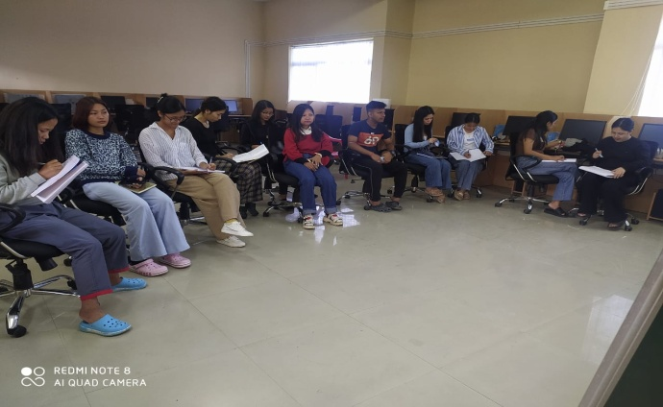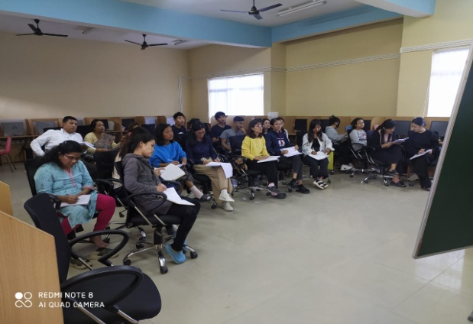
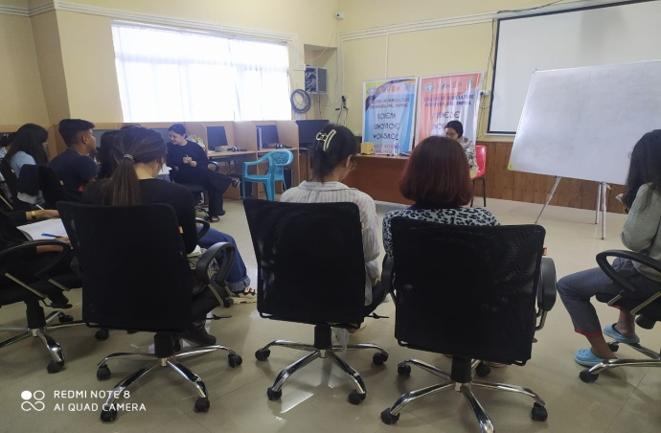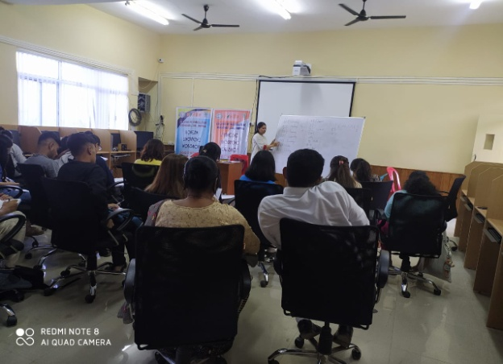

Glimpse of Korean Language Class

- On 27th October and 2nd November 2022, French language class was conducted online for students of BVSc & A.H. and MVSc. The activity was speaking practice through dialogues read by students from text book. Formation of negative sentences and other question forms taught and practiced through dialogues. Based on "Connexions" French textbook.

- General English classes for two UG batches, and Remedial Classes in Language Lab. for four batches by Ms. Lalrinmuani Kingbawl, Language Instructor, NAHEP-IDP CCS, Tura were conducted on 31st October, 1st, 2nd and 3rd November 2022.

Social Safeguard
Sl.No. | Date | Activities | Achieved | ST | SC | OBC | GEN | Total
 |  |  |  | Female | Female | Female | Female
1. | 31.10. 2022 | Course no. BSH 111, General English-I | 28 | 13 | 1 | 10 | 4 | 28
2 | 31.10. 2022 | Course no. BSH 111, General English-I | 13 | 7 | 0 | 5 | 1 | 13
3 | 1.11.2022 | Course no. BSH 111, General English-I | 41 | 22 | 1 | 15 | 3 | 41
4 | 31.10.2022 | Remedial class- ND 2nd Year | 13 | 4 | 0 | 4 | 5 | 13
5 | 1.11.2022 | Remedial class- ND 3rd Year | 9 | 5 | 0 | 3 | 1 | 9
6 | 2.11.2022 | Remedial class- CS 4th Year | 5 | 4 | 0 | 1 | 0 | 5
7 | 3.11.2022 | Remedial class- CS 3rd Year | 8 | 5 | 2 | 1 | 0 | 8

