WEEKLY REPORT FROM 26th August to 1st September, 2022
CAU, Imphal
- The Language Instructor under IDP-NAHEP, faculty members as well as students of the college participated in the online Language Lab Software Training by Sanako India. The training for the Language Instructors and faculty members was hosted on Monday, 29th August 2022 at 11 AM whereas the training for the students was held in two parts during 29 – 30th August 2022 at 2:30 PM. In the training, the students and faculty members placed their queries before the trainer for smooth running of the Language Laboratory at the college.
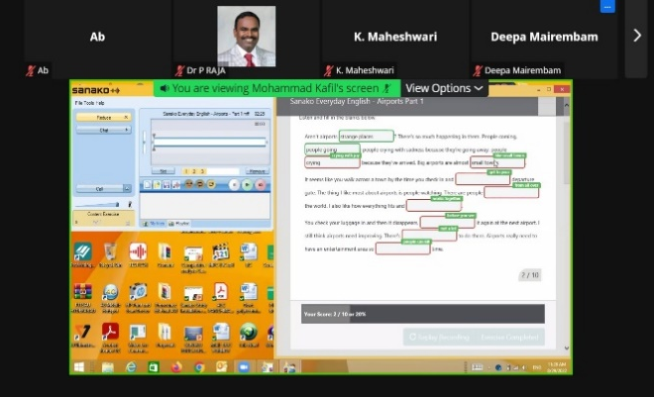
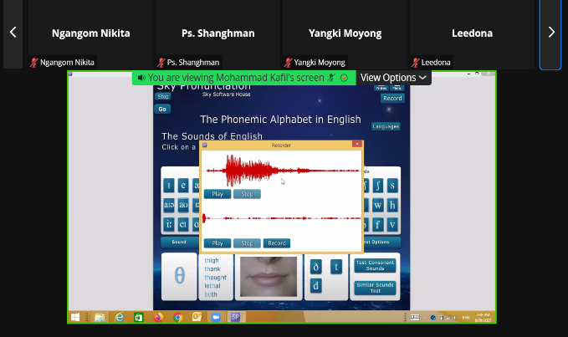

Photo: Language Laboratory Software training held online during 29-30 August, 2022

- On 25th and 31st August 2022. Lalrinmuani Kingbawl, language Instructor, IDP NAHEP,
College of Community Science. Tura conducted Technical Writing (BSH-123) classes for B Sc. (Hons.) Community Science and Food Nutrition & Dietetics. Topics for the classes were Letter Writing practice continues and Proposal Writing: Definition, kinds of proposals, format.

SOCIALSAFEGUARDs
Sl no. | Date | Activities | Target | Achieved | ST | SC | OBC | GEN | Total
 |  |  |  |  | Female | Female | Female | Female
1. | 25.08.2022 | Course no. BSH 123, Technical Writing | 56 | 48 | 20 | 1 | 20 | 7 | 48
 | 31.08.2022 | Course no. BSH 123, Technical Writing | 56 | 51 | 22 | 1 | 20 | 8 | 51

- On 29th August 2022, Mr. Md. Kafil from Sanako India Pvt. Ltd., New Delhi gave training on the Language Software for the Language Laboratory. The training was hosted by College of Community Science, Tura and participated by the faculties and students of the university.
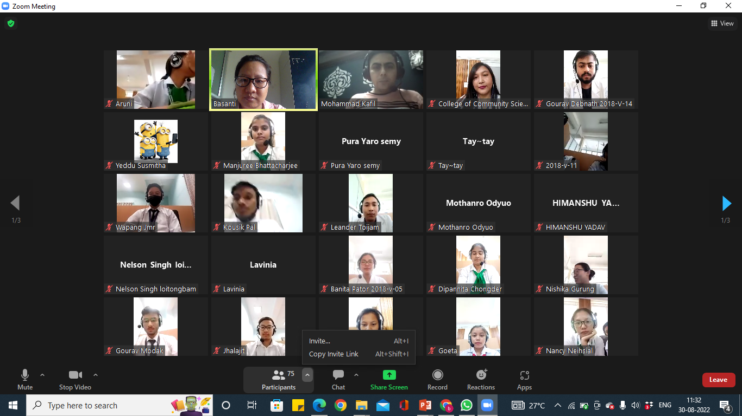

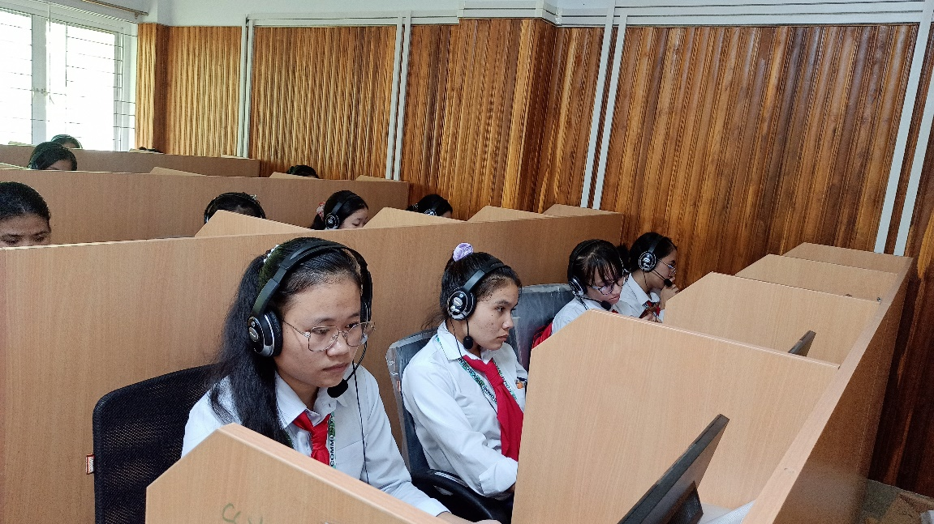
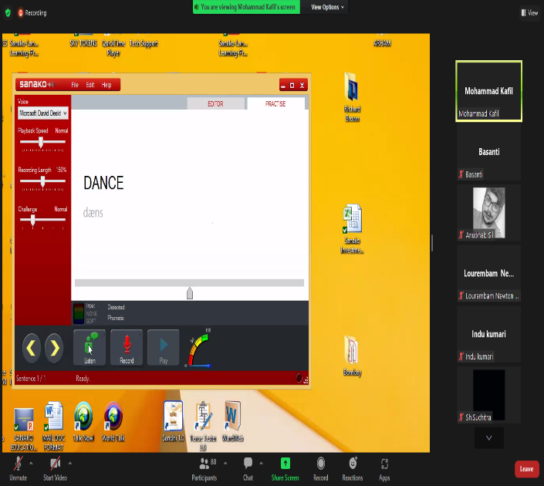

Photo: Training on Language Laboratory Software

- Presentation of reports for foreign training, College of Agriculture, Imphal: A total of 11 students made detailed PPT presentation on the work done and skills learned at IRRI, phillipines on 26th August 2022 at 11.30 am at virtual classrom. The presentation was attended by Dean of CoA, Iroisemba and other faculty members and scientists.
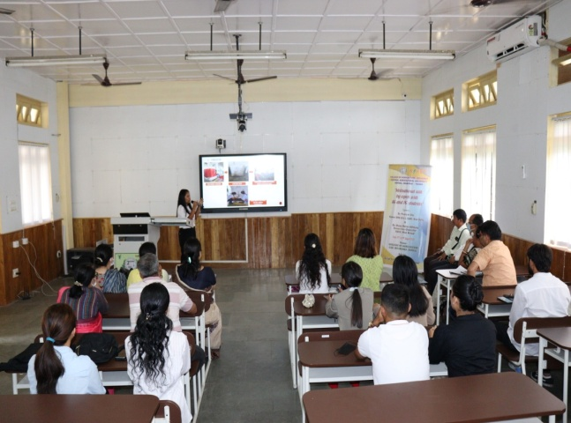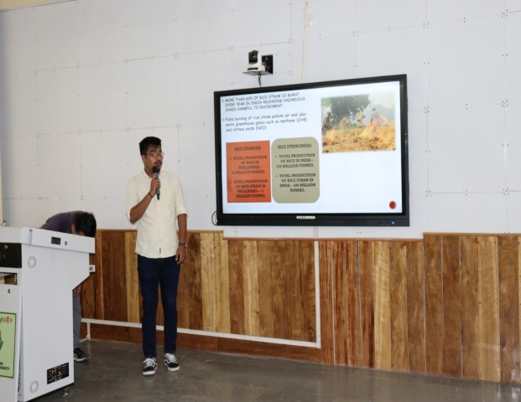
Photo: Students making presentation on Foreign training they have undergone
- Training on entrepreneurial-ecosystem: Dr. Daya Ram has undergone Online Training Programme on “Nurturing the Entrepreneurial Ecosystem in Agricultural Universities” from August 23-27, 2022 (under NAHEP) conducted by ICAR – NAARM-Hyderabad.
- Three faculty (Dr. Maheswari Devi, Dr. Stina Devi and Dr. Deepa Devi) of College of Agriculture, Imphal have undergone online training of English software hoisted by CCS, Tura during 29th and 30th August 2022 for smooth functioning of Language Laboratory.
Social Safeguard
(Online English Language Software Training)
Sl no | Details/date | Achieved | ST |  |  | SC |  |  | GEN |  |  | OBC
 |  |  | F | M | T | F | M | T | F | M | T | F | M | T
1 | 29th August 2022 | 12 | 3 | 1 | 4 | 0 | 0 | 0 | 0 | 2 | 2 | 2 | 4 | 6
F = Female, M = Male, and T = Total
- On 29th August UG first year students have undergone use of English Software in Language Laboratory hoisted online by CCS, Tura. Total 12 students attended the class, out of which 4 were ST, 6 from OBC and 2 from unreserved category. Gender wise 5 were female and 7 were male students.

