WEEKLY REPORT FROM 22nd to 28th July, 2022
CAU, Imphal

Social Safeguard
(Workshop on Japanese and Korean language)
Sl no | Details/date | Achieved | ST |  |  | SC |  |  | GEN |  |  | OBC
 |  |  | F | M | T | F | M | T | F | M | T | F | M | T
1 | 26th July 2022 | 45 | 8 | 5 | 13 | 3 | 3 | 6 | 7 | 4 | 11 | 10 | 5 | 15
2 | 27th July 2022 | 37 | 6 | 4 | 10 | 1 | 3 | 4 | 6 | 3 | 9 | 9 | 5 | 14
3 | 28th July 2022 | 38 | 3 | 5 | 8 | 3 | 4 | 7 | 6 | 5 | 11 | 7 | 5 | 12
F = Female, M = Male, and T = Total
- On 26th, 27th and 28th July, 2022, a 4-day workshop on Japanese and Korean Language began with Japanese Language followed by Korean language at College of Agriculture, Imphal. The instructors were Shri. Phurailatpam Nandakumar Sharma, Guest Faculty (Japanese Language), Department of Foreign Language, Manipur University, Canchipur; Loukrakpam Chingkheilembi, Guest Faculty (Japanese Language), Department of Foreign Language, Manipur University, Canchipur; Flourish Kamei, Teaching Assistant (Korean Language), Department of Foreign Language, Manipur University, Canchipur and Dr. Ahanthem Romita Devi, Assistant Professor (Korean Language), Department of Foreign Language, Manipur University, Canchipur . The Basics to Japanases and Korean language were taught in the sessions. A total of 45, 37 and 38 numbers of B.Sc., M.Sc. and Ph.D. students participated the workshop on 26th, 27th and 28th July respectively.
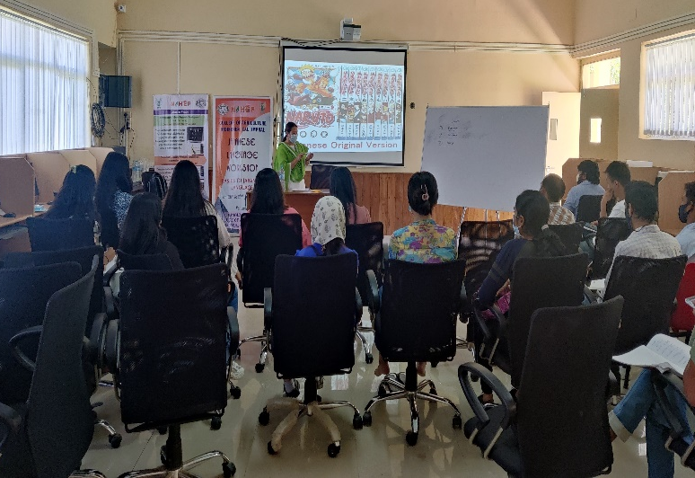
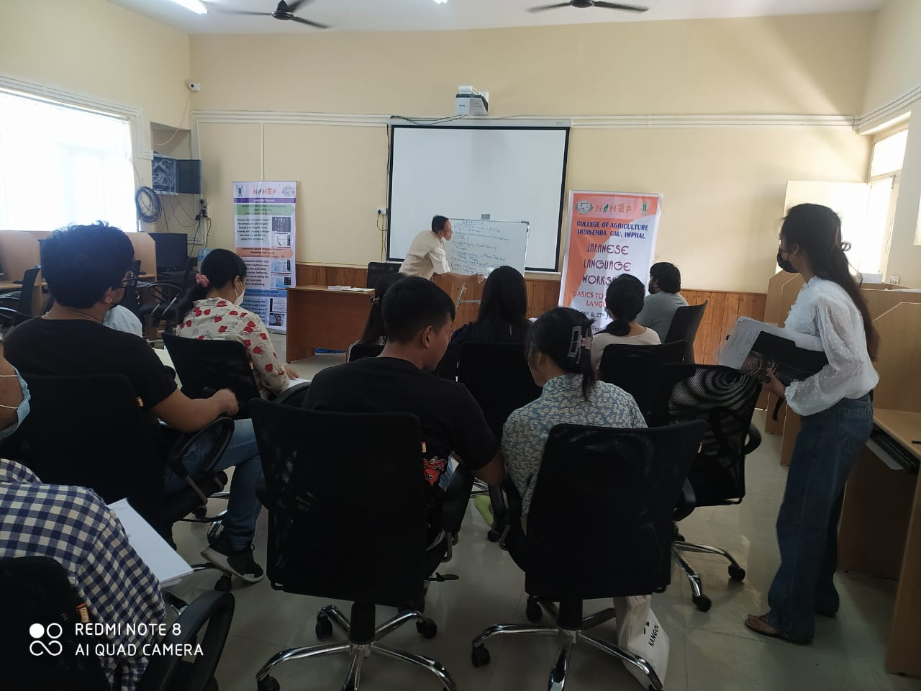

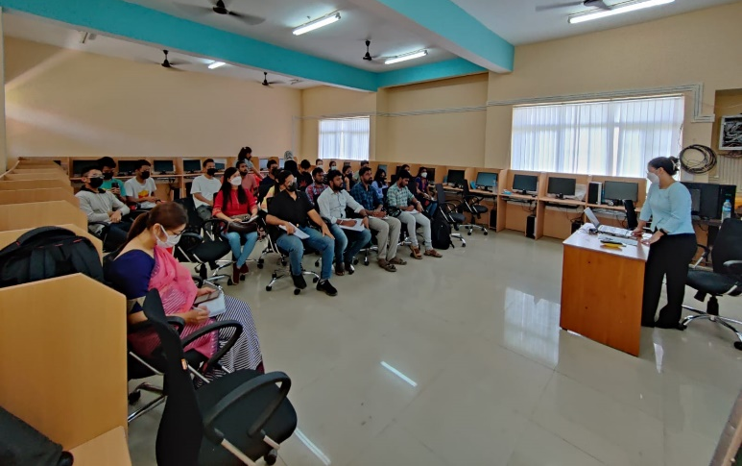
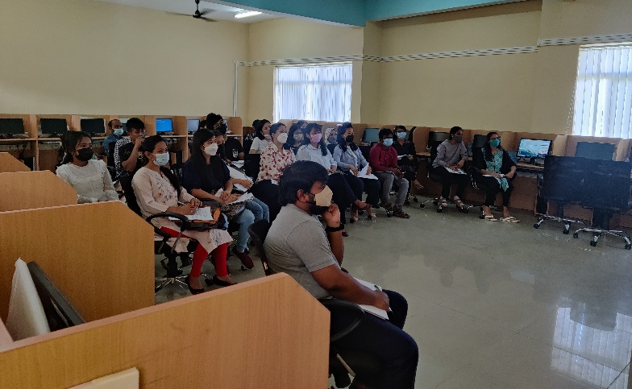

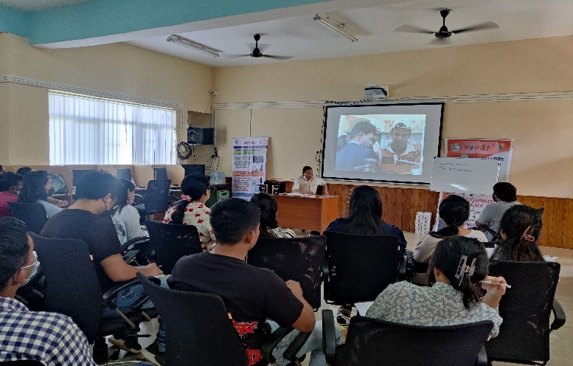
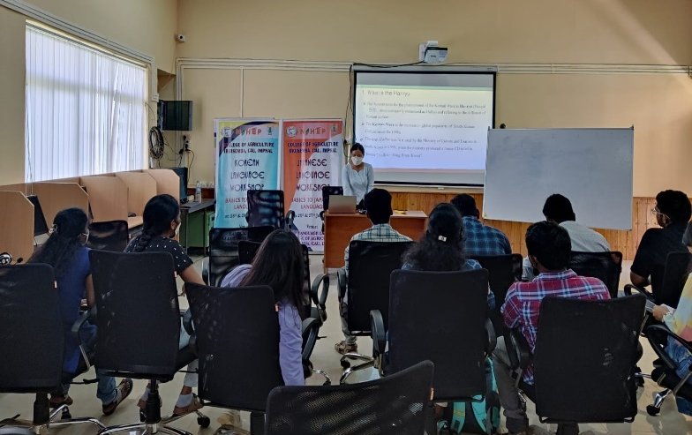

Photo 1: Workshop on Japanese and Korean Language held on 26th, 27th and 28th July 2022

- College of Community Science, Tura is organising 3 days Entrepreneurship Development Programme from 26th July to 28th July 2022. Resource persons of the programme are Mr. Jefferson Rani, Manager, Entrepreneurship Ecosystem Development, PRIME Startup Hub, Meghalaya; Mr Sandeep Sabharwal, Deshpande Foundation, Hubbali , Karnataka; Ms. Jacquiline Swer, Incubation Manager, PRIME Startup Hub, Meghalaya; Dr. Suman Nandy, CEO, BIRAC, (B31) Facility, NEHU, Tura campus; and Mr. Mahesh Masal, Human Mindset Corporate Trainer, Coach & Author, Bangalore.

