WEEKLY REPORT FROM 23rd September to 29th September, 2022
CAU, Imphal
- A guest lecture on the topic "Scientific Intervention for Environmental Sustenance through Startups" was delivered by Prof. Shaon ray Chaudhuri, professor, Department of Microbiology, tripura University at College of Fisheries, Lembucherra on 27th September 2022 under IDP NAHEP of CAU Imphal. The lecture was organised as part of a series of lectures stressing the need for environmental sustainability with regard to entrepreneurship in recent times, especially in the Agri and Fisheries sectors worldwide
SOCIAL SAFEGUARDs/Gender Equity Chart
SL No | Activities | Target | Achieved | ST |  | SC |  | OBC |  | GEN |  | TOTAL
A. Capacity Building for Students
01. | Guest lecture on the topic “Scientific Intervention for Environmental Sustenance through Startups” (27/9/22) | B.F.Sc. 3rd & 4th year; M.F.Sc & PhD students of CoF, CAU (I) | 42 | F | M | F | M | F | M | F | M | 42
 |  |  |  | 10 | 8 | 3 | 1 | 5 | 8 | 1 | 6
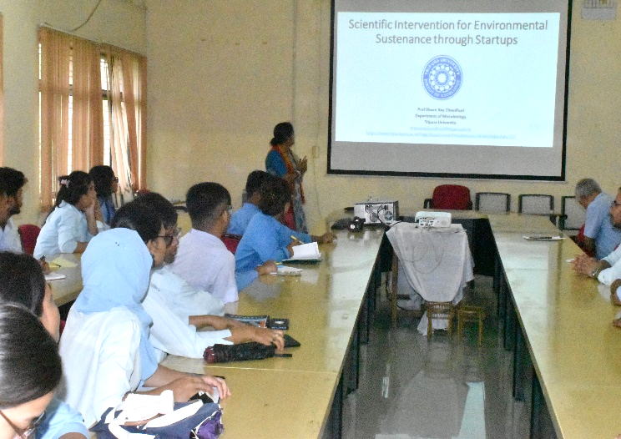
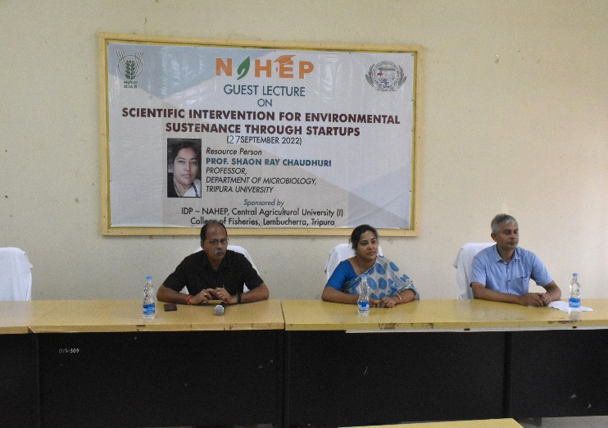

Fig. Photographs of the guest lecture on Scientific Intervention for enriromnental sustenance through startups conducted on 27 September 2022

- A Three days training on personality development and soft skills was organized at COA, Imphal. The experts came from Communicare, Pune. The session started at 9.30 am on 29/09/22. Total 40 students participated in the training programme, out of which 25 were female and the remaining was male. Total 12 students belonged to OBC, 12 to General, 11 to ST and 5 to SC.
Social Safeguard
(Three days training on personality development and soft skills)
Sl no | Details/date | Achieved | ST |  |  | SC |  |  | GEN |  |  | OBC
 |  |  | F | M | T | F | M | T | F | M | T | F | M | T
1 | 29th September 2022, (Thursday) | 40 | 9 | 2 | 11 | 2 | 3 | 5 | 7 | 5 | 12 | 7 | 5 | 12
F = Female, M = Male, and T = Total
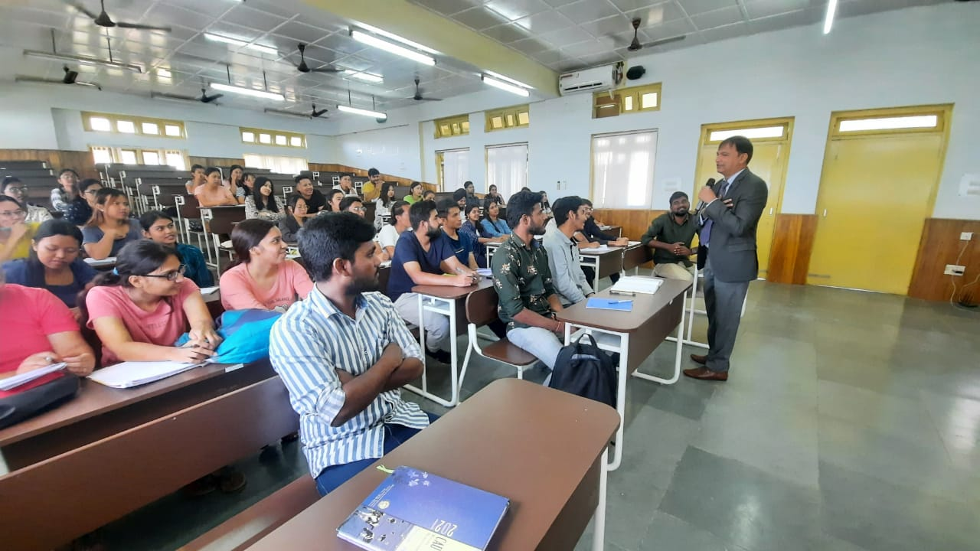
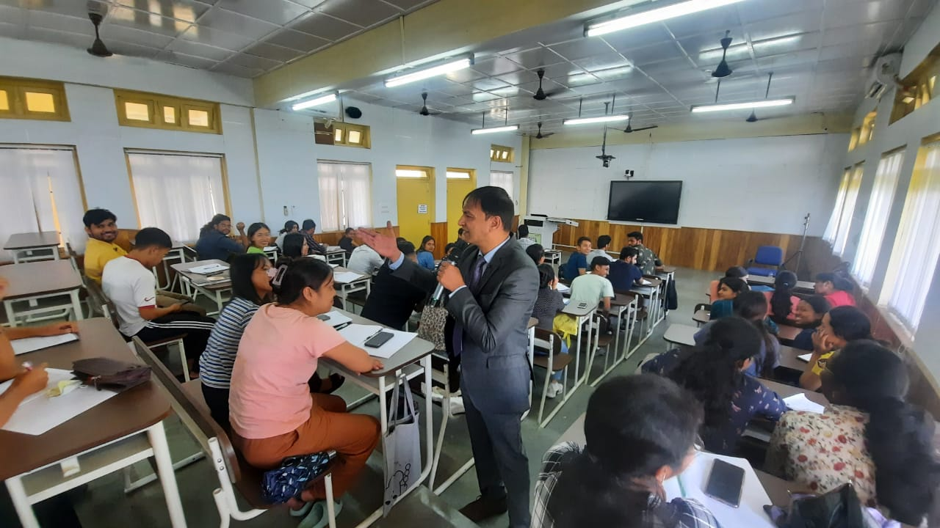

Photo: Students interacting with the expert on first session on 29th September 2022

- At College of Agriculture, Imphal, Training of UG students in Paper recycling unit was held on 23rd and 26th September 2022; Total 19 students participated in which 11 were male and 8 were female. Eight of them were from ST category, 4 from SC category, 5 from OBC category and 2 from General category.
Social Safeguard
(Hands-on training programme for paper recycling)
Sl no | Details/date | Achieved | ST |  |  | SC |  |  | GEN |  |  | OBC
 |  |  | F | M | T | F | M | T | F | M | T | F | M | T
1 | 23rd September 2022, (Friday ) | 10 | 3 | 0 | 3 | 0 | 2 | 2 | 1 | 2 | 2 | 2 | 1 | 3
2 | 26th September 2022, (Monday) | 9 | 3 | 2 | 5 | 0 | 2 | 2 | 0 | 0 | 0 | 0 | 2 | 2
 |  |  | 6 | 2 |  | 0 | 4 |  | 1 | 2 |  | 2 | 3
F = Female, M = Male, and T = Total

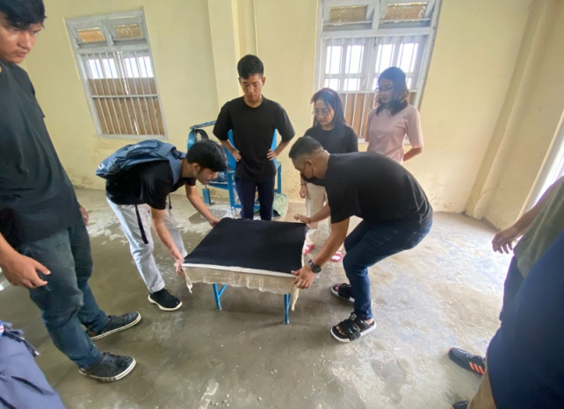
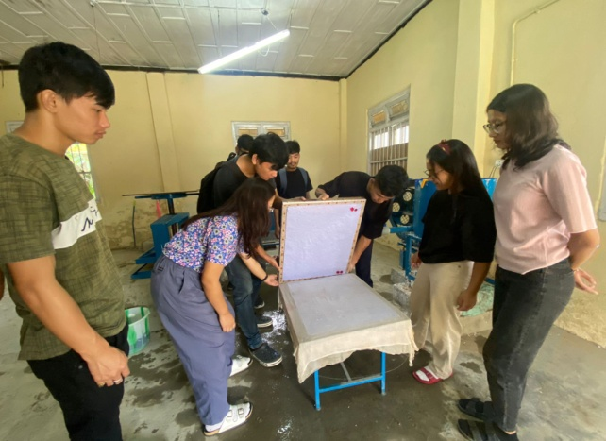

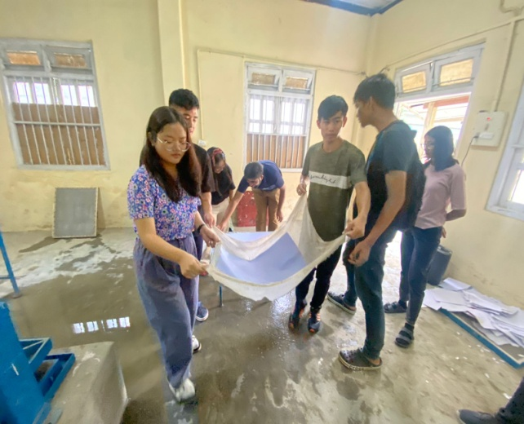
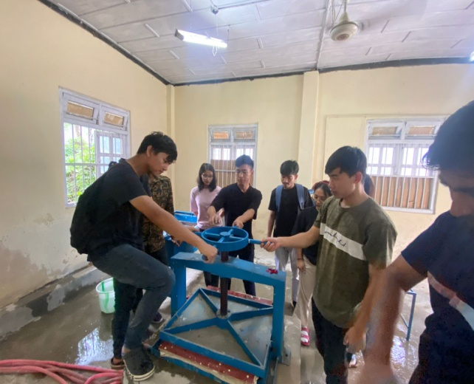

Photo: UG students working in paper recycling unit
- General English (BSH 111) for: B Sc. (Hons.) Community Science and Food Nutrition & Dietetics students of College of Community Science, Tura was taken by IDP NAHEP Language Instructor Lalrinmuani Kingbawl on 26th and 27th September 2022.
SOCIAL SAFEGUARDs
 |  |  |  |  |  | Students participated
Sl no. | Date | Activities | Target | Achieved |  | ST | SC | OBC | GEN |  | Total
 |  |  |  |  |  | Female | Female | Female | Female
Conducting English class for two UG batches by Ms. Lalrinmuani Kingbawl, Language Instructor, NAHEP-IDP CCS, Tura
1. | 26.09.2022 | Course no. BSH 111, General English-I | 42 | 18 | 10 |  | - | 6 | 2 | 18
2. | 27.09.2022 | Course no. BSH 111, General English-I | 14 | 14 | 8 |  | - | 5 | 1 | 14

- On 22nd and 23rd September, 2022, French language classes were conducted online for students of BVSc & A.H. On 22nd September, the total number of participants was 22. The class started with revision of personal pronouns taught in previous class. Pairs of students were made to read aloud introductory dialogues from Connexions, French textbook, with special attention to pronunciation as taught in previous class. Conjugations of French verbs être and avoir were taught, exercises based on both verbs done by students through the Powerpoint. The class was based on “Connexions”, French textbook and a customized Powerpoint presentation prepared by Ms. Jaya. On 23rd September, the total number of participants was 10.The class started with revision of être and avoir verbs, through sentences to be formed given as homework to students in previous class. French verb “parler” was taught with conjugation of other regular verbs. Counting numbers from 1 to 20 was taught, with special attention to pronunciation. Definite and indefinite articles were introduced through examples via Powerpoint.

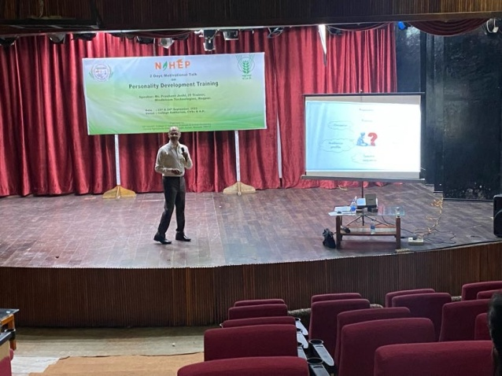
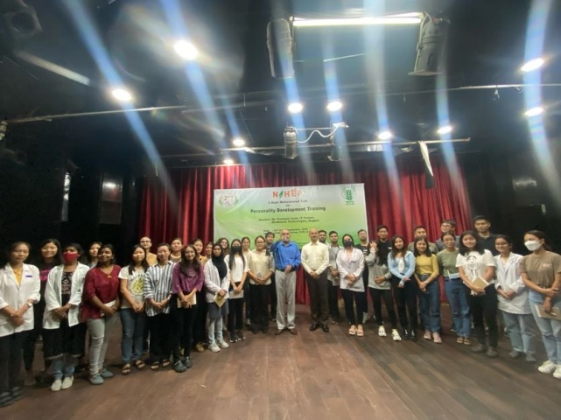
- On 23rd and 24th September, 2022, 2 days training on Personality Development was conducted for undergraduate students. On 23rd September, 2022 the training was conducted in 2 sessions at the College Auditorium, the first session from 1:30 – 2:30 pm and the second session from 3:00 – 4:00 pm. The total number of participants was 47. The training programme started with a brief introduction of the speaker by Dr. V.V. Kulkarni. The speaker Mr. Prashant Joshi, IT Trainer, Mindbloom Technologies, Nagpur delivered talks on “Smart world, Smarter Future” and “Stage Presentation Skills”. On 24th September, 2022, the training was conducted at the Seminar Hall of ADM block at 9:30-10:30 am and 11:00 am-12:00 pm. The total number of participants was 44. The speaker Mr. Prashant Joshi delivered talks on “Email Marketing” and “Soft Skill Softies”. The programme ended with vote of thanks by Dr. J.B. Rajesh. The participants along with the speakers and coordinators were provided lunch after the training.
23rd September, 2022 at College Auditorium

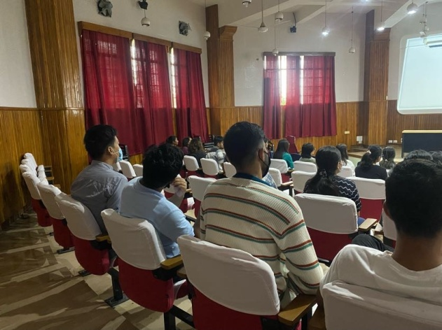
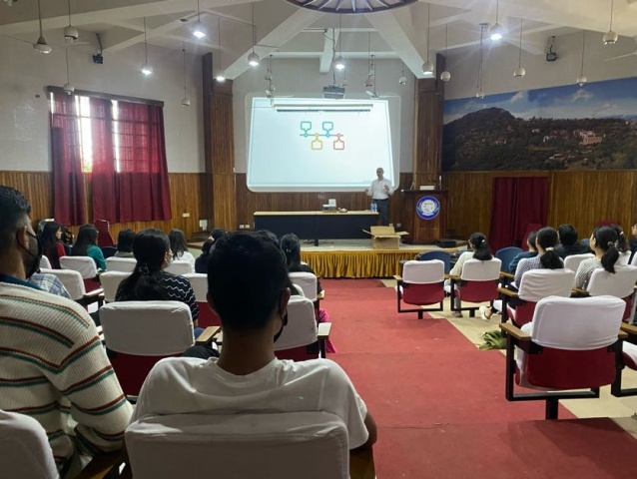

24th September, 2022 at Seminar Hall, ADM Block
SOCIAL SAFEGUARD
Sl no | Activities | Target | Achieved | ST |  | SC |  |  | GEN |  |  | OBC |  | Others |  | TOTAL
 |  |  |  | M | F | M | F |  | M |  | F | M | F | M | F
A |  |  | B. Capacity Building for students
1. | Language class | BVSc & A.H | 22.09.22 : French Language class | 5 | 6 | 1 |  | 1 |  | 3 | 2 | 2 | 2 | 0 | 0 | 22
2. | Language class | BVSc & A.H | 23.09.22 : French Language class | 2 | 3 | 1 |  | 0 |  | 2 | 1 | 1 | 0 | 0 | 0 | 10
3. | National Training | UG students | 23.09.22 : Personality Development Training | 4 | 11 | 0 |  | 3 |  | 8 | 4 | 11 | 7 | 0 | 0 | 47
4. | National Training | UG students | 24.09.22 : Personality Development Training | 4 | 10 | 0 |  | 3 |  | 7 | 4 | 10 | 6 | 0 | 0 | 44
 |  |  |  | Grand Total |  |  |  |  |  |  |  |  |  |  |  | 123

