WEEKLY REPORT FROM 14TH – 21ST JULY, 2022
- College of Veterinary Sciences and Animal Husbandry, Selesih, Mizoram conducted a Language class on 14th, 15th and 19th July 2022 for 4th year, 2nd year and 1st year BVSc students repsectively. The topic was Phonology in English. A brief introduction to phonology was explained along with the rules and organization and patterns of sounds with respect to English language. For the 1st BVSc students, a set of random 20 words in phonemic transcription was generated by the software which the students have to decode by listening to each sound of the given transcribed words. The exercise helps in mastering the sounds of English by listening and associating the phonemic alphabets with its sound.
SOCIAL SAFEGUARD
Sl no | Activities | Target | Achieved | ST |  | SC |  |  | GEN |  |  | OBC |  | Others |  | TOTAL
 |  |  |  | M | F | M | F |  | M |  | F | M | F | M | F
A |  |  | B. Capacity Building for students
1 | Language Class | 4th year BVSc Group A & B | 14.07.22 : Language Class | 0 | 2 | 0 |  | 0 |  | 1 | 0 | 2 | 0 | 0 | 0 | 5
2 | Language Class | 2nd year BVSc | 15.07.22 : Language Class | 1 | 0 | 0 |  | 0 |  | 0 | 0 | 0 | 0 | 0 | 0 | 1
3 | Language Class | 1st year BVSc Group A & B | 19.07.22 : Language Class | 0 | 1 | 2 |  | 0 |  | 0 | 2 | 2 | 2 | 0 | 0 | 9
 |  |  |  | Grand Total |  |  |  |  |  |  |  |  |  |  |  | 15

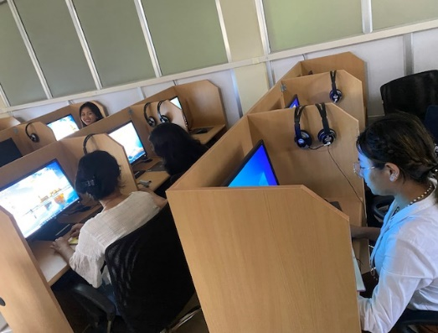
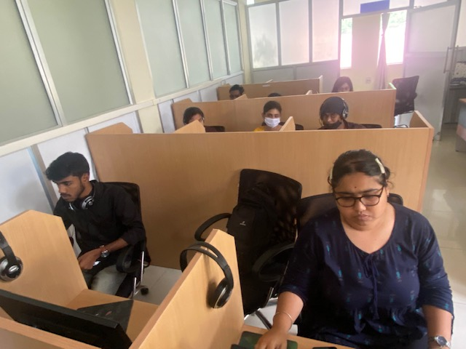

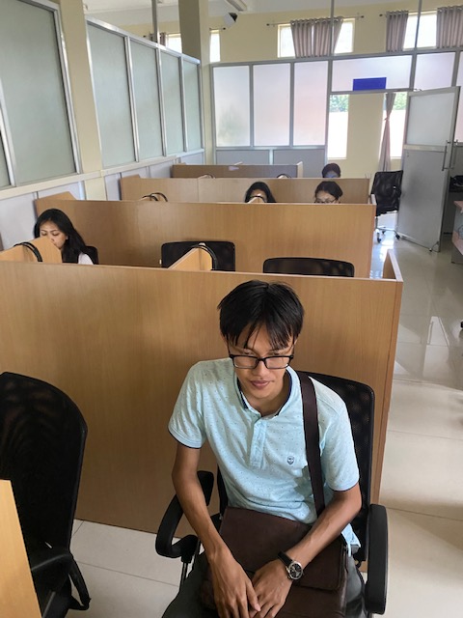
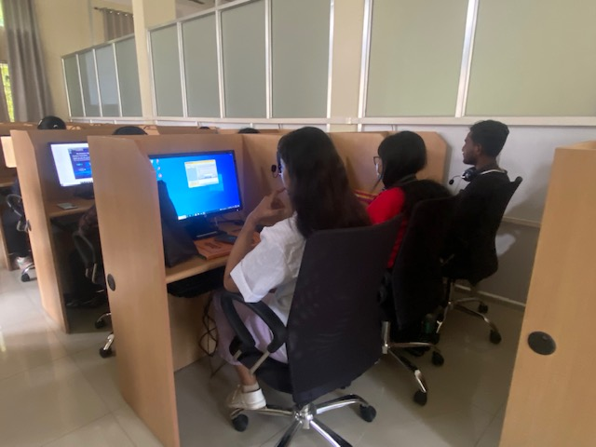

Photo: Language class on Phonology and phonemic transcription held at College of Veterinary Sciences and Animal Husbandry, Selesih, Mizoram on 14th, 15th and 19th July 2022
- Student’s foreign training Screening committee meeting was held at College of Community Science, Tura on 20th July 2022. A total of 14 applications from interested B.Sc. 3rd year Community Science students were received based on criteria which is a minimum of 7.5 CGPA.

