WEEKLY REPORT FROM 14th October to 20th October, 2022
CAU, Imphal

SOCIAL SAFEGUARDs/Gender Equity Chart
SL No | Activities | Target | Achieved | ST |  | SC |  | OBC |  | GEN |  | TOTAL
A. Capacity Building for Students
01. | Special lectures on the topic “Women entrepreneurship development in fisheries” ” (15/10/22) | B.F.Sc. 3rd & 4th year; M.F.Sc & PhD students of CoF, CAU (I) | 101 | F | M | F | M | F | M | F | M | 101
 |  |  |  | 23 | 20 | 2 | 8 | 14 | 11 | 10 | 13
- Two special lectures on the topic “Women entrepreneurship development in fisheries” was delivered by Dr Kanta Das Mahapatra, Principal Scientist, ICA-CIFA, Bhubaneswar at College of Veterinary Science & AH, Selesih during National Women Farmers’ Day i.e. on 15 October 2022 under the aegis of IDP-NAHEP. The lectures were aimed at bolstering entrepreneurship spirit among the students
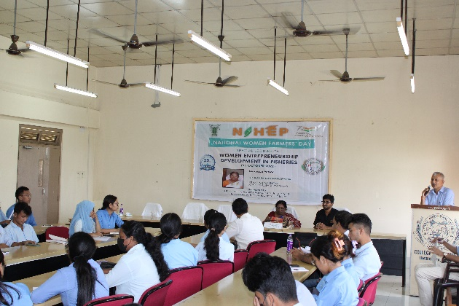
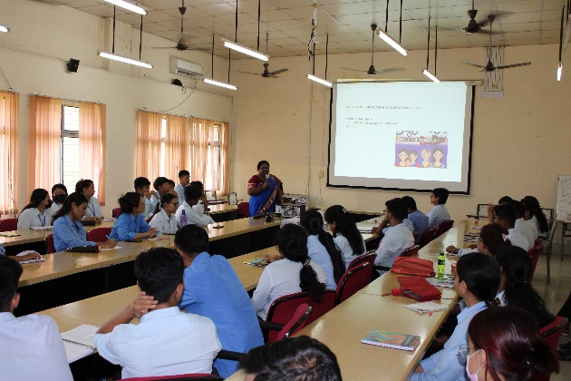

Photos: Lectures on the topic “Women entrepreneurship development in fisheries” on 15/10/22

- College of Agriculture, Imphal is organising a short term course 3 months on “Korean Language Course for Beginners”. The inaugural programme for the said course was held on 20th October 2022 at the Main auditorium of the college.

