WEEKLY REPORT FROM 9th September to 15th September, 2022
CAU, Imphal

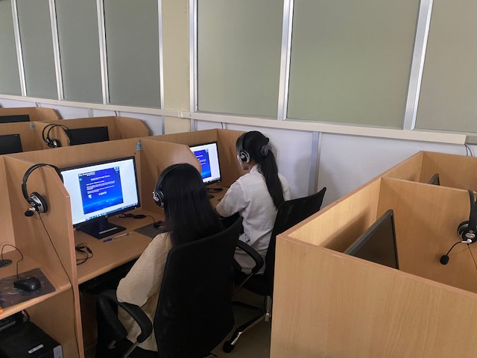
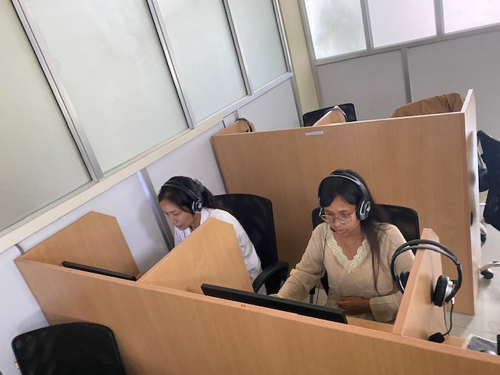
- Two language classes were conducted at College of Veterinary Sciences & AH, Aizawl by IDP NAHEP Language instructor on 13th and 14th September 2022 The class was focused on practical usage of the language software. A brief outline of word stress rules was discussed then the students were given task on Word and Phrasal stress in Sky Pronunciation tool. They were given time to read and understand the rules of word stress and then practice on the exercises provided by the software.

Photo: Students attending language software

SOCIAL SAFEGUARD
Sl no | Activities | Target | Achieved | ST |  | SC |  |  | GEN |  |  | OBC |  | Others |  | TOTAL
 |  |  |  | M | F | M | F |  | M |  | F | M | F | M | F
A |  |  | B. Capacity Building for students
1. | Language Class | 1st year BVSc & A.H. Group B | 13.09.22 : Language class | 0 | 2 | 0 |  | 0 |  | 0 | 0 | 0 | 0 | 0 | 0 | 2
2. | Language Class | 4th year BVSc & A.H. | 14.09.22 : Language class | 0 | 2 | 0 |  | 0 |  | 0 | 0 | 0 | 0 | 0 | 0 | 2
 |  |  |  | Grand Total |  |  |  |  |  |  |  |  |  |  |  | 4

