WEEKLY REPORT FROM 7th October to 13th October, 2022
CAU, Imphal
- Training of UG students of College of Agriculture, Imphal in paper recycling unit was held on 10th and 12th October 2022; Total 20 students participated in which 14 were male and 6 were female. Four of them were from ST category, 7 from SC category, 3 from OBC category and 6 from General category.
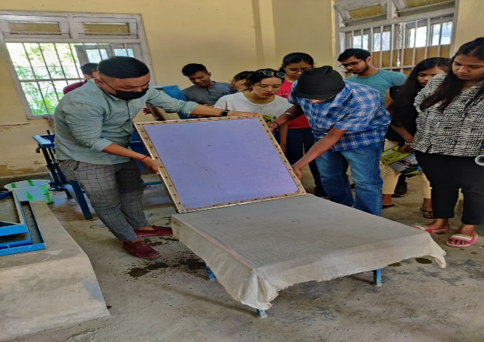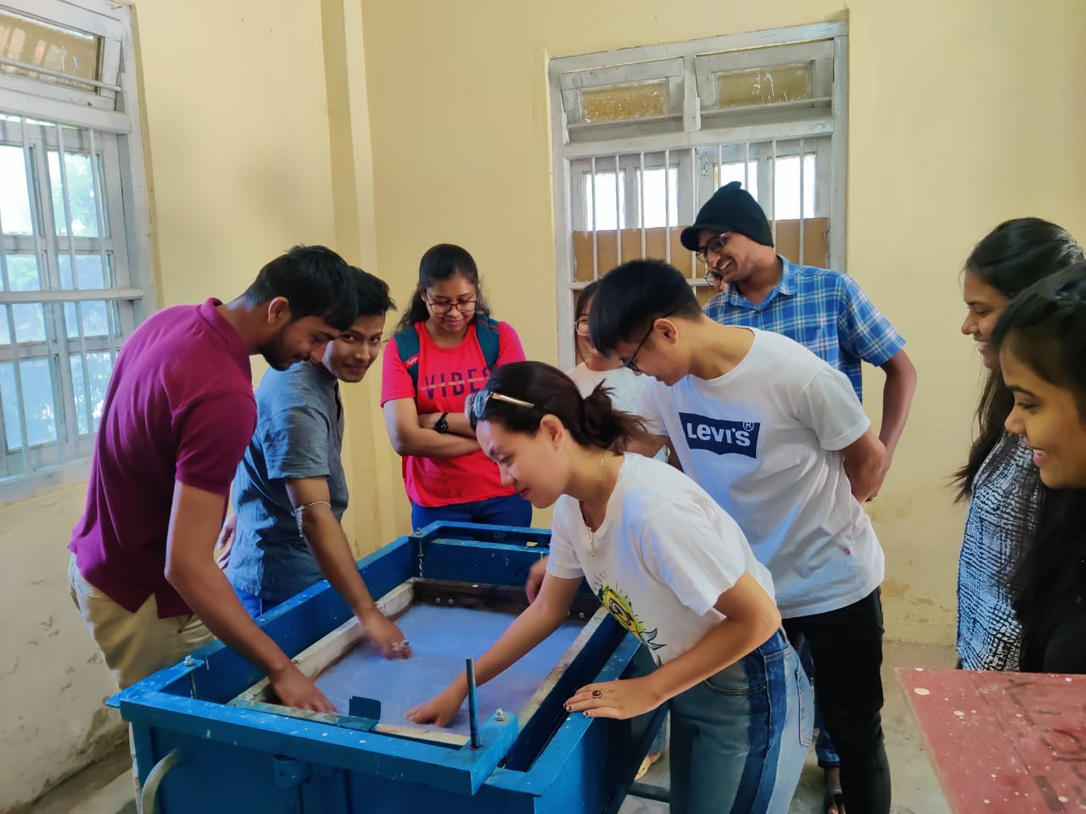
UG students working in paper recycling unit

Social Safeguard
(Hands-on training programme for paper recycling)
Sl no | Details/date | Achieved | ST |  |  | SC |  |  | GEN |  |  | OBC
 |  |  | F | M | T | F | M | T | F | M | T | F | M | T
1 | 10th October 2022, (Monday) | 11 | 1 | 1 | 2 | 3 | 1 | 4 | 0 | 2 | 2 | 1 | 2 | 3
2 | 12th October 2022, (Wednesday) | 9 | 0 | 2 | 2 | 0 | 3 | 3 | 1 | 3 | 4 | 0 | 0 | 0
F = Female, M = Male, and T = Total

- On 7th October, 2022, French language class was conducted for students of BVSc & A.H., College of Veterinary Science & Animal Husbandry, Selesih. The total number of participants was 4. Revision of nationalities and numbers given as homework to students in previous class. French interrogative words introduced and sentences formed by students. Counting numbers from 1 to 100 taught, with special attention to pronunciation. Based on "Connexions 1" french textbook and a customized PowerPoint prepared by Ms. Jaya.
SOCIAL SAFEGUARD
Sl no | Activities | Target | Achieved | ST |  | SC |  |  | GEN |  |  | OBC |  | Others |  | TOTAL
 |  |  |  | M | F | M | F |  | M |  | F | M | F | M | F
1. | Language class | BVSc & A.H and MVSc | 7.10.22 : French Language class | 8 | 4 | 0 |  | 0 |  | 5 | 2 | 0 | 0 | 0 | 0 | 19

- Two days faculty development programme “Intellectual Property, Technology and Incubation Management” organised on 26th to 27th September, 2022 at College of Post Graduate Studies in Agricultural Sciences, Umiam, Meghalaya of CAU, Imphal. The FDP was attended by 50 faculty members (13 female and 37 male). Dr. K. Srinivas, ADG, IPTM, New Delhi, Dr. Manju Gerard, PR Scientist IPTM unit, ICAR, New Delhi were the resource persons for the FDP. “Innovation ecosystem in India”, challenges in agriculture and opportunities for agri-startups, Farm Development Card - A holistic approach and customised plan for the farmer, on Intellectual Property issues and Patents in new age business, Technology commercialisation in NARS, Business plan- Basic Concept and description- Business Environment Analysis-Techno entrepreneurs, IP protection, How to proceed with the filing were some of the key discussion areas.

Programme details:

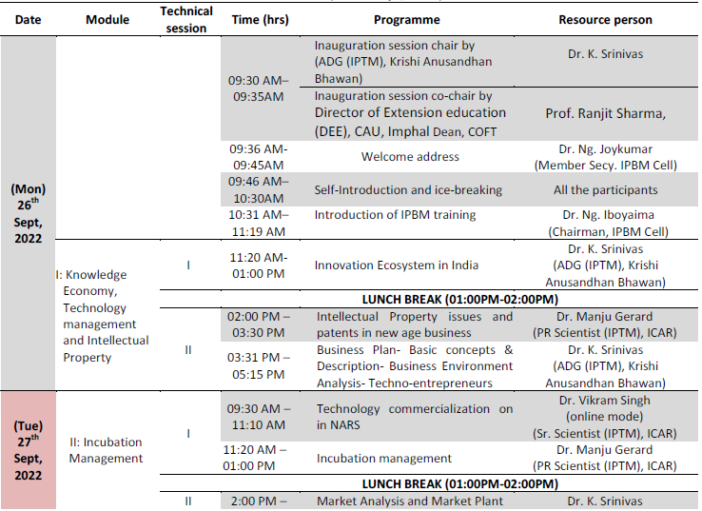

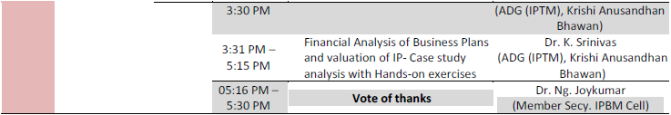

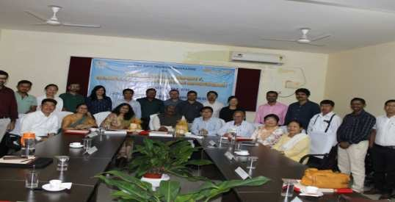
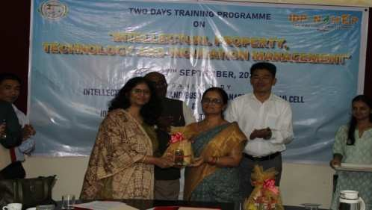
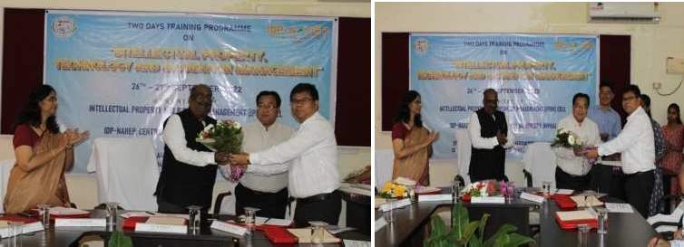
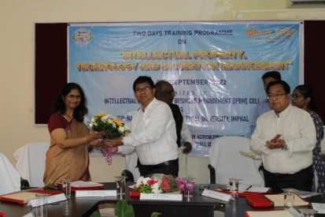
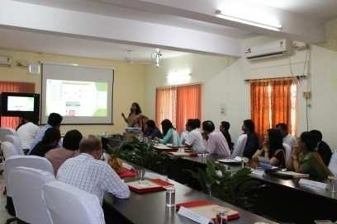
Some photos of the Faculty Development programme on IPBM

