Weekly activities of the IDP- NAHEP under Central Agricultural University, Imphal
(1st July to 7th July, 2022)

- Three-day invited lectures on “Advances in Extension, Education & Research” organised by department of Fisheries Extension, Economics & Statistics, COF, CAU(I), under IDP-NAHEP has been concluded on 30th June, 2022 at college ATIC Hall. In the 3rd and last day of the lectures Dr. Puranjan Das, former DDG (Ext.), ICAR, New Delhi delivered lectures on the topics Role of Extension in Global Perspectives and Extension Project Management & Impact Analysis, followed by lectures delivered by Dr. Manas Mohan Adhikary, former Vice-Chancellor, BCKV, West Bengal on the topics Advances of training & Human Resource Development in Extension and Extension Communication Strategies & Approaches. A total of 30 students of the college attended the same.
SOCIAL SAFEGUARD
SL No | Activities |  | Target | Achieved | ST |  | SC |  | OBC |  | GEN |  | TOTAL
A. Capacity Building for Students
01. | 3rd and last day of invited lectures on “Advances in Extension, Education & Research (30/06/2022) | B.F.Sc. and PG student of the college |  | 30 | F | M | F | M | F | M | F | M | 30
 |  |  |  |  | 4 | 1 | 1 | 2 | 8 | 4 | 5 | 5

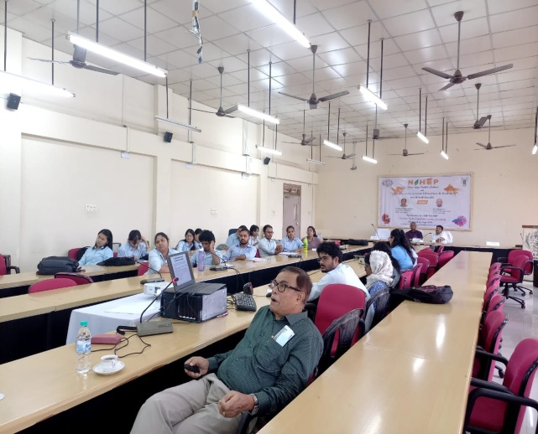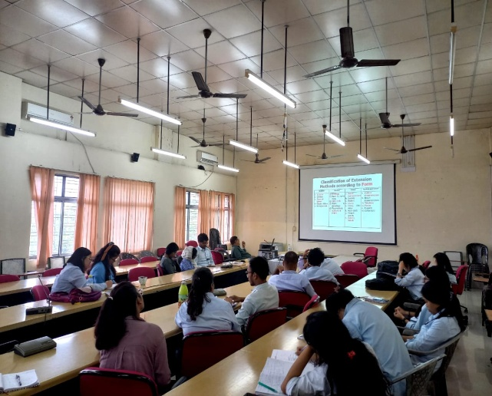
Photo: 3rd & last day of the of invited lectures on Advances in Extension, Education & Research

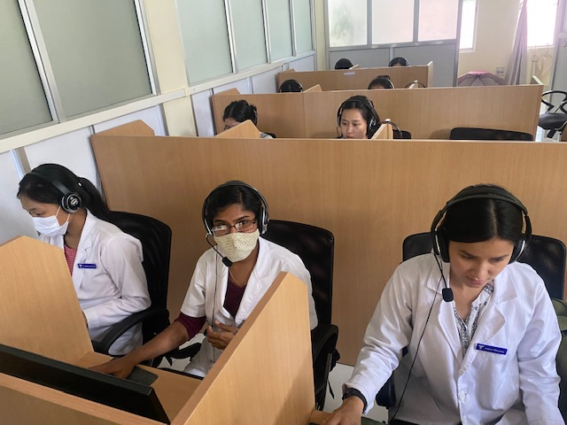
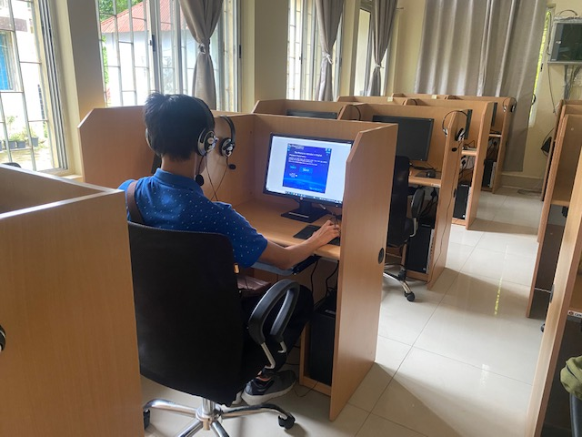
- A Language class was conducted for 4th year BVSc, Group A and B of College of Veterinary Science, Selesih in the Language Laboratory. The total number of attendance was 10. The students are given tasks of Transcribing on Sky Pronunciation. A set of random 20 words in phonemic transcription was generated by the software which the students have to decode by listening to each sound of the given transcribed words. The task is repeated until they get a minimum score of 18 out of 20. The exercise helps in mastering the sounds of English by listening and associating the phonemic alphabets with its sound.

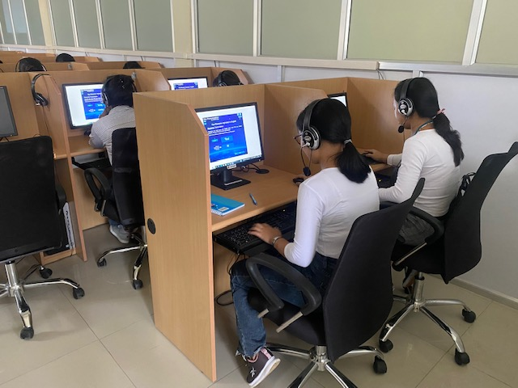
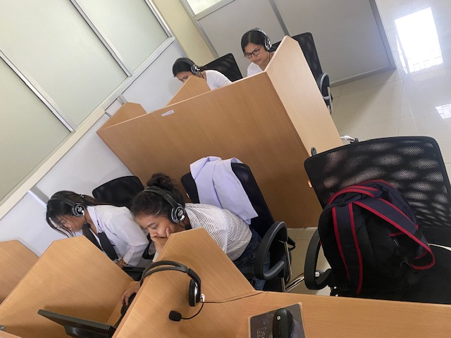

Photo: Student in the Language laboratory

SOCIAL SAFEGUARD
Sl no | Activities | Target | Achieved | ST |  | SC |  |  | GEN |  |  | OBC |  | Others |  | TOTAL
 |  |  |  | M | F | M | F |  | M |  | F | M | F | M | F
A |  |  | B. Capacity Building for students
1 | Language Class | 4th year BVSc Group A & B | 30.06.22 : Language Class | 0 | 5 | 0 |  | 1 |  | 1 | 1 | 0 | 2 | 0 | 0 | 10
 |  |  |  | Grand Total |  |  |  |  |  |  |  |  |  |  |  | 10

- College of Community Science, Tura conducted three general class for BSc. ND & CS 1st Year Semester 2 (Technical Writing, Course No. BSH 123 on 30th, 4th and 6th July 2022 and one general class for BSc. ND & CS 2nd Year (Communication Skills and Personality Development) on 6th July 2022.

SOCIALSAFEGUARDs
 |  |  |  |  | Students participated
Sl no. | Date | Activities | Target | Achieved | ST | SC | OBC | GEN |  | Total
 |  |  |  |  | Female | Female | Female | Female
Conducting regular English classes for four UG batches by Ms. Lalrinmuani Kingbawl, Language Instructor, NAHEP-IDP CCS, Tura
1. | 30.06.2022 | Course no. BSH 123, Technical Writing | 56 | 50 | 20 | 1 | 20 | 9 | 50
2. | 04.07.2022 | Course no. BSH 123, Technical Writing | 56 | 51 | 22 | 1 | 19 | 9 | 51
3. | 06.07. 2022 | Course no. BSH 123, Technical Writing | 56 | 54 | 24 | 1 | 20 | 9 | 54
4. | 06.07. 2022 | Course no. BSH 249 Communication Skills & Personality Development | 32 | 26 | 10 | 2 | 11 | 3 | 26

