WEEKLY REPORT FROM 30th September to 6th October, 2022
CAU, Imphal
- A Three days training on personality development and soft skills was organized. The experts came from Communicare, Pune. The session started at 9.30 am on 29/09/22. Total 40 students participated in the training programme.

Social Safeguard
(Three days training on personality development and soft skills)
Sl | Details/date | Total | ST |  | SC |  | GEN |  | OBC
 |  |  | F | M | F | M | F | M | F | M
1 | 29th September 2022 | 40 | 9 | 2 | 2 | 3 | 7 | 5 | 7 | 5
F = Female, M = Male, and T = Total

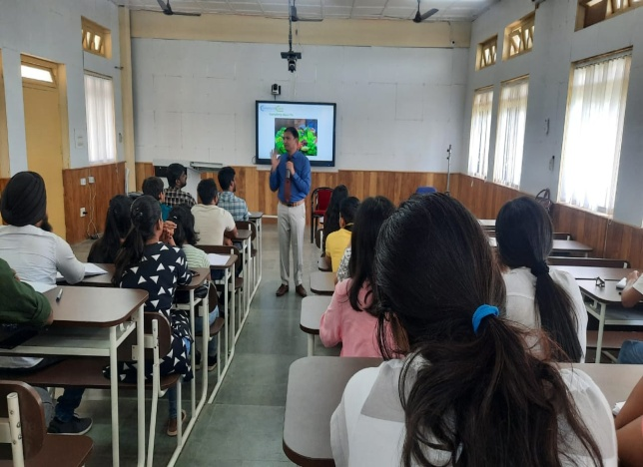
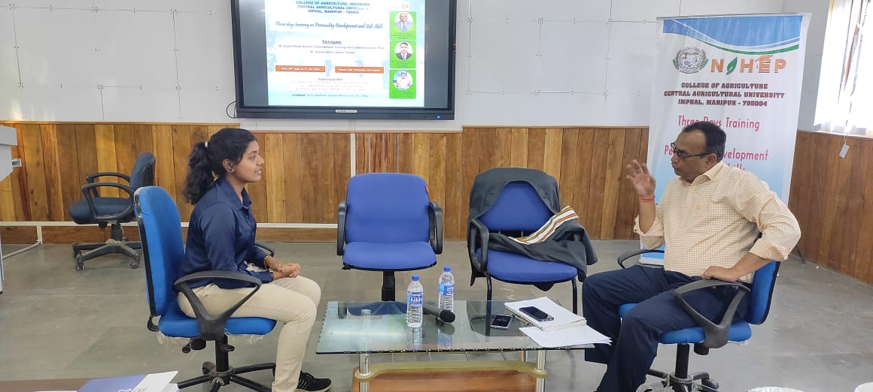

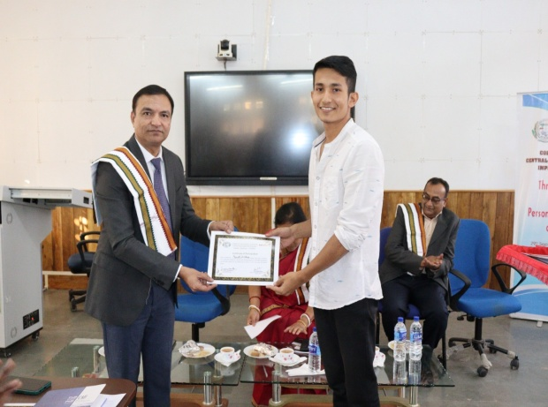
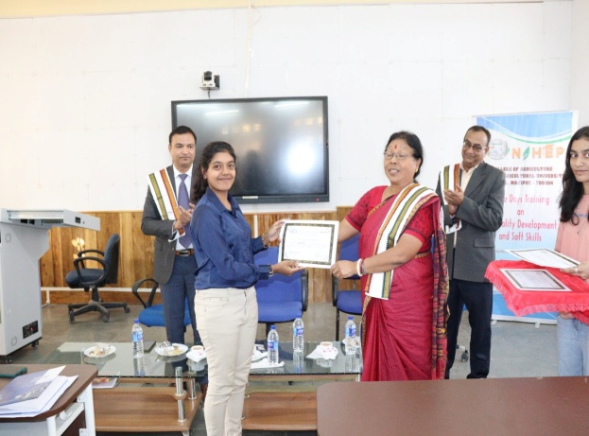

Glimses of practical session and veledictory session on 30th September and 1st October 2022

- On 29th and 30th September, 2022, French language classes were conducted online for students of BVSc & A.H. and MVSc, College of Veterinary Science & AH, Selesih. The total number of participants was 10. Revision of regularly used french verbs, through sentences formed by students. French descriptive phrases and prepositions taught using which students formed sentences. Revision of definite and indefinite articles through examples via PowerPoint. Students were asked to download and refer to a mobile dictionary to build up their French vocabulary.
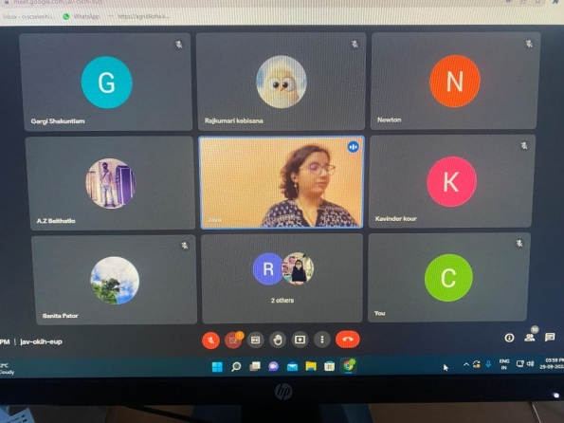
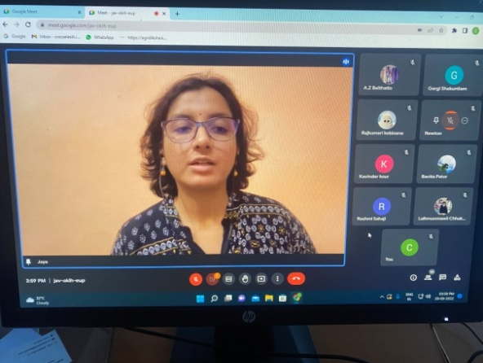

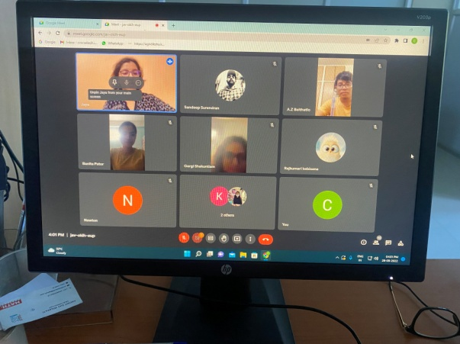
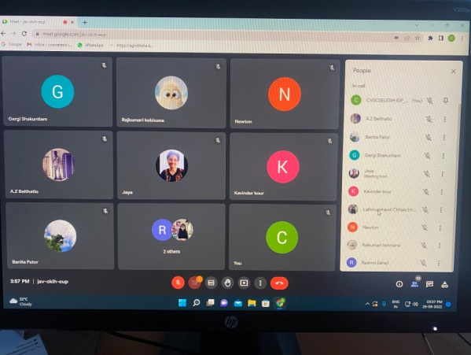

SOCIAL SAFEGUARD
Sl no | Achieved | ST |  | SC |  | GEN |  | OBC |  | TOTAL
 |  | M | F | M | F | M | F | M | F
1. | 29.09.22: French Language class | 2 | 3 | 1 | 0 | 1 | 2 | 1 | 0 | 10

- IDP NAHEP Language Instructor Lalrinmuani Kingbawl, College of Community Science, Tura conducted General English (BSH 111) for: B Sc. (Hons.) Community Science and Food Nutrition & Dietetics students of College of Community Science on 3rd and 4th October 2022. Introduction to software in Language Lab, Practical work on Phonetics was taken up on 3rd October and Word Formation: Processes and rules on 4th October.

SOCIALSAFEGUARDs
Sl no. | Date | Activities | ST | SC | OBC | GEN | Total
 |  |  | Female | Female | Female | Female
1. | 3.10.2022 | Course no. BSH 111, General English-I | 17 | 1 | 14 | 3 | 35
2. | 4.10.2022 | Course no. BSH 111, General English-I | 20 | - | 13 | 8 | 41

