WEEKLY REPORT FROM 2nd September to 8th September, 2022
CAU, Imphal

- A two-day workshop on “ROLE OF PERSONALITY IN ENTREPRENEURSHIP” has been conducted at College of Fisheries, CAU (I) during 7 – 8 September 2022. The resource person of the workshop, Dr. E. V. Divakara Sastry Ex-Professor, Department of Genetics and Plant Breeding, College of Agriculture, CAU (I) Imphal, Manipur delivered a total of four (4) lectures. A total of 67 & 57 UG 3rd and 4th year students of the college participated in the workshop on 1st and 2nd day of the program respectively.

SOCIAL SAFEGUARDs/Gender Equity Chart
SL No | Activities | Target | Achieved | ST |  | SC |  | OBC |  | GEN |  | TOTAL
A. Capacity Building for Students
01. | 1st day of the workshop on “Role of personality in Entrepreneurship” (07/09/2022) | B.F.Sc. 3rd & 4th year student of the college | 67 | F | M | F | M | F | M | F | M | 67
 |  |  |  | 23 | 10 | 5 | 2 | 9 | 6 | 4 | 8
02. | 2nd day of the workshop on “Role of personality in Entrepreneurship” (08/09/2022) |  | 57 | 22 | 10 | 4 | 1 | 7 | 4 | 3 | 6 | 57
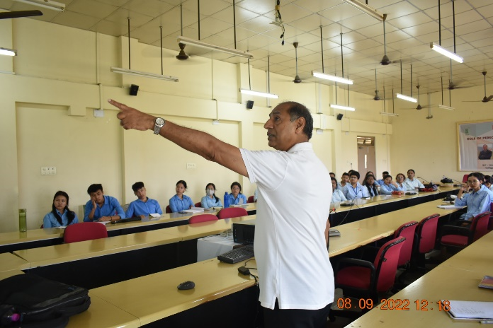 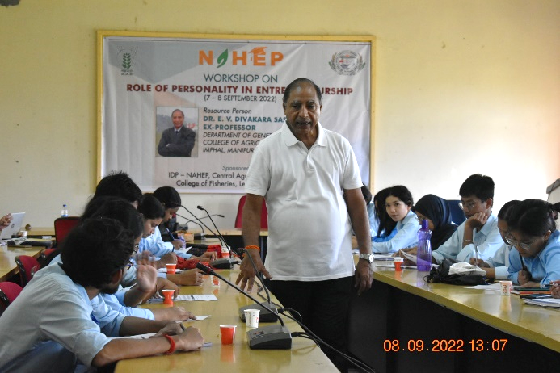
Photo: Workshop on “ROLE OF PERSONALITY IN ENTREPRENEURSHIP

- Two language classes were conducted at College of Veterinary Sciences & AH, Aizawl by IDP NAHEP Language instructor on 1st and 2nd September 2022. The class was focused on practical usage of the language software, Word and Phrasal Stress, Speed Reading. The students practiced exercises on Stress and Rhythm.
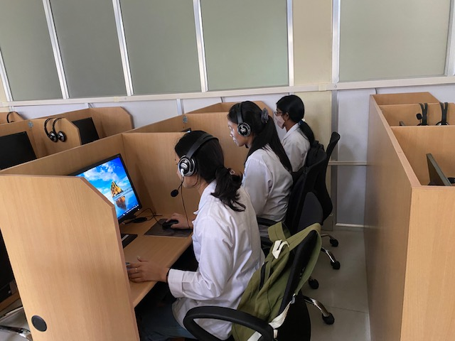
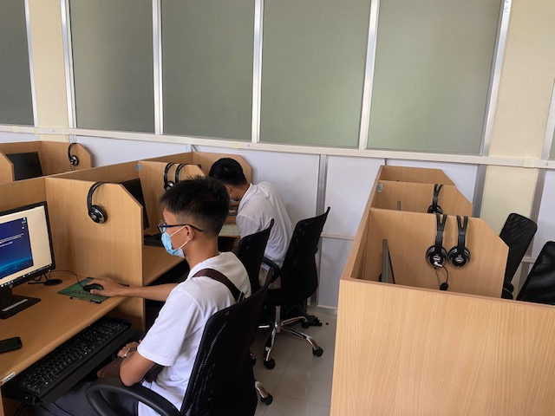

Photo: Students attending language software

SOCIAL SAFEGUARD
Sl no | Activities | Target | Achieved | ST |  | SC |  |  | GEN |  |  | OBC |  | Others |  | TOTAL
 |  |  |  | M | F | M | F |  | M |  | F | M | F | M | F
1. | Language Class | 4th year BVSc & A.H. | 1.09.22 : Online Language Laboratory Software Training | 1 | 1 | 0 |  | 1 |  | 1 | 1 | 1 | 0 | 0 | 0 | 6
2. | Language Class | 1st year BVSc & A.H. Group B | 2.09.22 : Online Language Laboratory Software Training | 0 | 4 | 1 |  | 0 |  | 0 | 0 | 0 | 0 | 0 | 0 | 5
 |  |  |  | Grand Total |  |  |  |  |  |  |  |  |  |  |  | 11

