Weekly activities of the IDP- NAHEP under Central Agricultural University, Imphal
(8th April -14th April, 2022)

- Online classes of SSAC for B.Sc. students of College of Agriculture, Iroishemba, Imphal took place on 1st, 4th, 6th, 8th, 11th and 13th April, 2022. The classes were conducted by Dr. Mohan Chandra Talukdar, Retired Professor, Dept. of Soil Science, AAU, Jorhat, Assam.
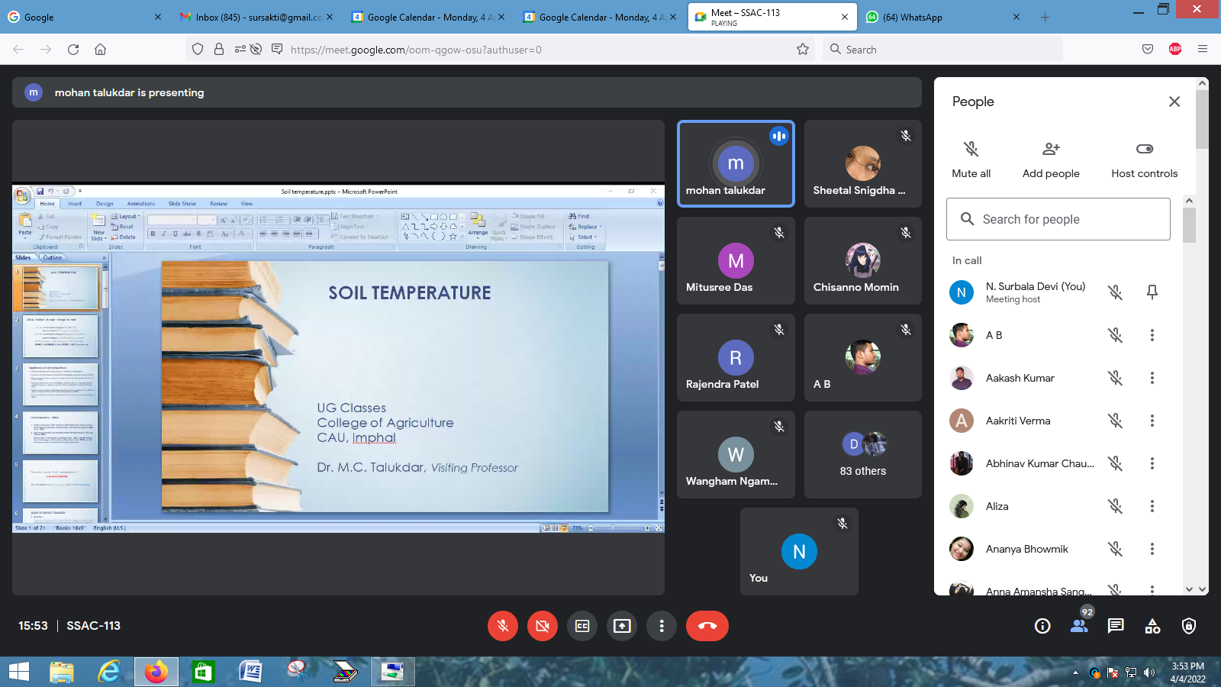
Photo: Screenshot of the online class
Social Safeguard
Sl no | Class Details  (SSAC-113) | Achieved | ST |  |  | SC |  |  | GEN |  |  | OBC
 |  |  | F | M | T | F | M | T | F | M | T | F | M | T
1 | 01-04-22 | 86 | 22 | 14 | 36 | 2 | 1 | 3 | 17 | 6 | 23 | 16 | 8 | 24
2 | 04-04-22 | 90 | 23 | 14 | 37 | 2 | 2 | 4 | 18 | 6 | 24 | 16 | 9 | 25
3 | 06-04-22 | 87 | 22 | 14 | 36 | 2 | 2 | 4 | 17 | 6 | 26 | 15 | 8 | 21
4 | 07-04-22 | 98 | 25 | 15 | 40 | 2 | 2 | 4 | 20 | 9 | 29 | 15 | 10 | 25
5 | 11-04-22 | 101 | 26 | 15 | 41 | 2 | 2 | 4 | 20 | 11 | 31 | 15 | 10 | 25
6 | 13-04-22 | 100 | 25 | 15 | 40 | 2 | 2 | 4 | 20 | 11 | 31 | 15 | 10 | 25
F = Female, M = Male and T = Total

- College of Community Science, Tura, Meghalaya conducted Communication Skills and Personality Development/ General English-I/Technical writing and Communication Skills classes for BSc. ND & CS 1st Year on 11th of April 2022 and for ND & CS 2nd Year on 13th April 2022.
SOCIAL SAFEGUARDs
 |  |  |  |  | Students participated
Sl no. | Date | Activities | Target | Achieved | ST |  | SC |  | OBC |  | GEN | Total
 |  |  |  |  | Female |  | Female |  | Female |  | Female
Conducting regular English classes(BSH 111 & BSH 249) for two UG batches by Ms. Lalrinmuani Kingbawl, Language Instructor, NAHEP-IDP CCS, Tura
1. | 11.04.2022 | BSc. ND & CS 1st Year : Phonetics- Consonant sounds | 57 | 55 | 21 | 6 |  | 16 |  | 12 |  |  | 55
2. | 13.04.2022 | BSc. ND & CS 2nd Year: Note Taking (Methods and Importance Note taking practice) | 33 | 31 | 16 | 3 |  | 6 |  | 6 |  |  | 31

- College of Horticulture and Forestry, Pasighat, Arunachal Pradesh has published a compendium under IDP-NAHEP Project “Shifting Value and new innovation in urban agriculture during the Covid - 19 crises”. The book is jointly authored by Dr. C.H. Victoria, Dr. A.S.Mailappa, Dr.P.Raja, Dr.N.Surmina Devi, Dr. Punabati Haisnam and Prof. B.N.Hazarika hving ISBN No. 978-81-947589-5-2.
