Weekly activities of the IDP- NAHEP under Central Agricultural University, Imphal (11th February – 17th February, 2022)

- College of Community Science, Tura, Meghalaya conducted Japanese language class on 10th and 11th February, 2022 for UG students. A total of 113 and 121 students attended the class on 11th and 12th February respectively.
- An online lecture on Entrepreneurial, IPR and Export was also conducted in College of Community Science on 14th February, 2022 at College of Community Sciences. 51 UG students – 47 online and 4 offline participated in the lecture.
Social Safeguards
No | Date | Activities | Target | Achieved | SC | ST | OBC | GEN
1 | Japanese Language Class
 | 10/2/22 | Japanese counters and register of language | 125 | 113 | 3 | 75 | 22 | 13
 | 11/2/22 | Japanese cuisines | 125 | 121 | 3 | 77 | 29 | 12
2 | 14/2/22 | Online lecture on Entrepreneurial, IPR and Export – Different IPR, GoI initiatives, trademark, patent infringement | 50 | 51 | 1 | 45 | 3 | 2
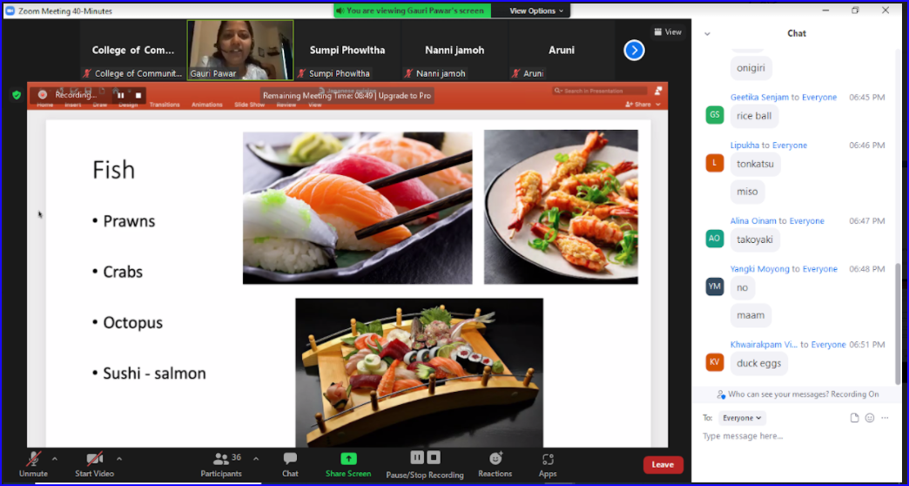
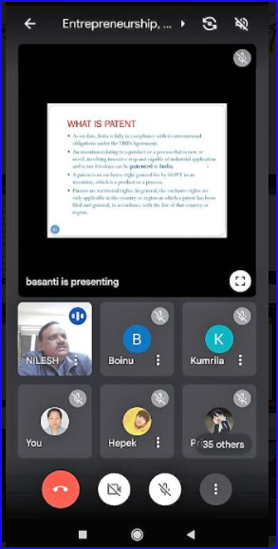

1. Photos: Screeshot of the Programmes – Japanese Cuisine 2.Photo: What is Patent
- College of Horticulture & Forestry, Pasighat organised webinar no. 38 “Success Master Class: Personality Development with Soft Skills learning”. The webinar was conducted for 14 days from 5th February 2022 to 12th February 2022. Main topics and key speakers of the event are as follows:
Speakers | Topics
Nameirakpam Jaswant Singh, IFS  Director, Dir. of Fisheries, Sikkim | How To Ace Any Job Interview
Dr. Sajib Borua Assoc. Professor,  EEI, AAU, Jorhat | Soft Skills For Effective Future Service
Dr. L. Devarani Assoc. Professor,  CPGS, CAU, Meghalaya | Self-Awareness For Effective Communication
Dr. Shivani Sharma  Image Consultant, Etiquette Coach & Soft Skills Trainer | How To Present Yourself Well During An Interview
Khangembam Ranjita Devi  CEO, State Institute of Hotel Management, Manipur | How To Polish Your Interview Skills
Ranjita Khaidem  Certified L&D Professional, Image  Coach & Soft Skills Trainer | Power Up Your Personal & Professional Image
Madhusmita Dutta Jr.Faculty, EEI, AAU, Jorhat | Effective Inter Personal Skills For Professionals

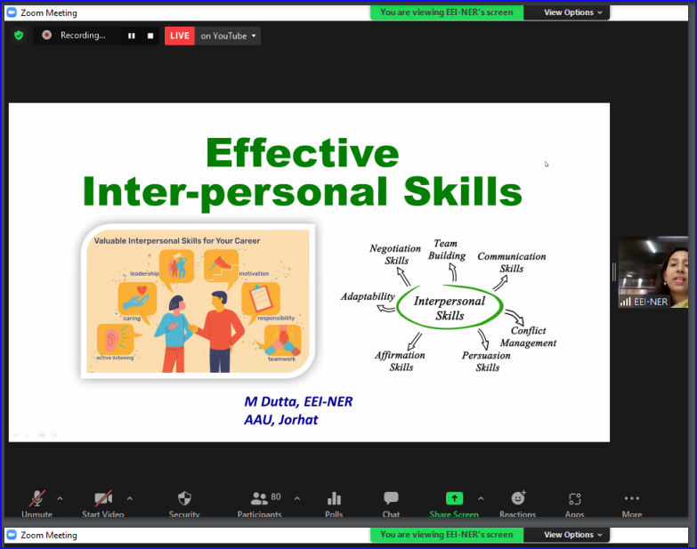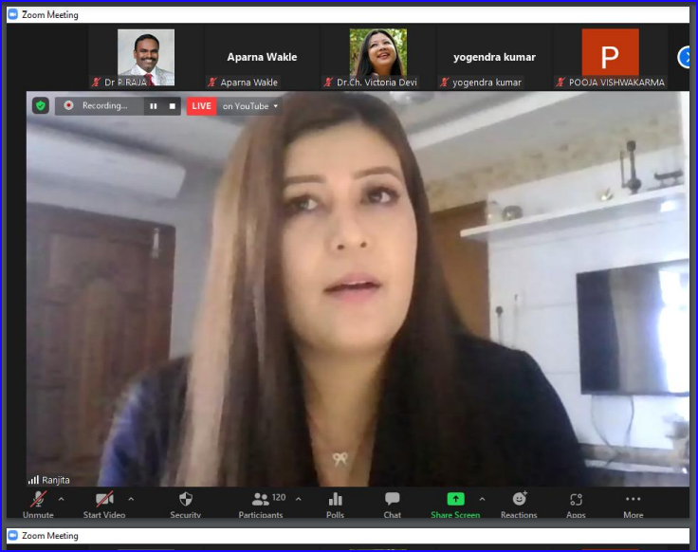
Photo: Screenshot of the the webinar: Success Master Class - Personality Development with Soft Skills learning

