**Weekly activities of the IDP- NAHEP under Central Agricultural University, Imphal (10th March – 17th March, 2022)**

* Dr.Dhananjoy Roy, Assistant Professor (English) Deptt. of BEAS,CAEPHT,Ranipool, Gangtok,Sikkim, has undertaken Communication Skills and Personality Development and English Language classes under IDP, NAHEP. A total of 30 students participated in the said classes.

|  |  |  |  |  |  |  |  |  |  |  |  |  |  |
| --- | --- | --- | --- | --- | --- | --- | --- | --- | --- | --- | --- | --- | --- |
| **SOCIAL SAFEGUARDs** | | | | | | | | | | | | | |
| Sl. No | | Activities | Target | Achieved | ST | | SC | | Gen | | OBC | | |
| Dr.Dhananjoy Roy, Assistant Professor (English) Deptt. of BEAS,CAEPHT,Ranipool, Gangtok,Sikkim, has covered the following courses | | | | | F | M | F | M | F | M | F | M | |
|  | | | | | | | | | | | | | |
| 1 | BSH 116: Communication Skills and Personality Development (B.Sc.-Horticulture)  **(14.03.2022-15.03.2022)** | | 19 | 19 | 13 | 02 | 01 | 0 | 0 | 0 | 0 | | 03 |
| 2 | BSH 1116:English Language  **(16.03.2022-17.03.2022)** | | 11 | 11 | 04 | 01 | 0 | 0 | 0 | 01 | 01 | | 04 |
|  |  | |  |  |  |  |  |  |  |  |  | |  |

* Preparation for the organisation of the Global and Regional Alumni Meet 2022 in six constituent colleges of the CAU, Imphal on 26th and 27th March 2022 is going on in full swing. Around 1000 alumni are expected to be present physically and virtually in the meet.
* Installation of 7Kw OnGrid Solar power plant in all the 7 campuses of the university including HQ, CAU, Imphal is completed and operational now.

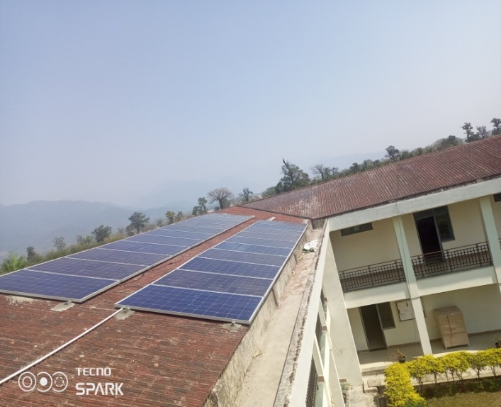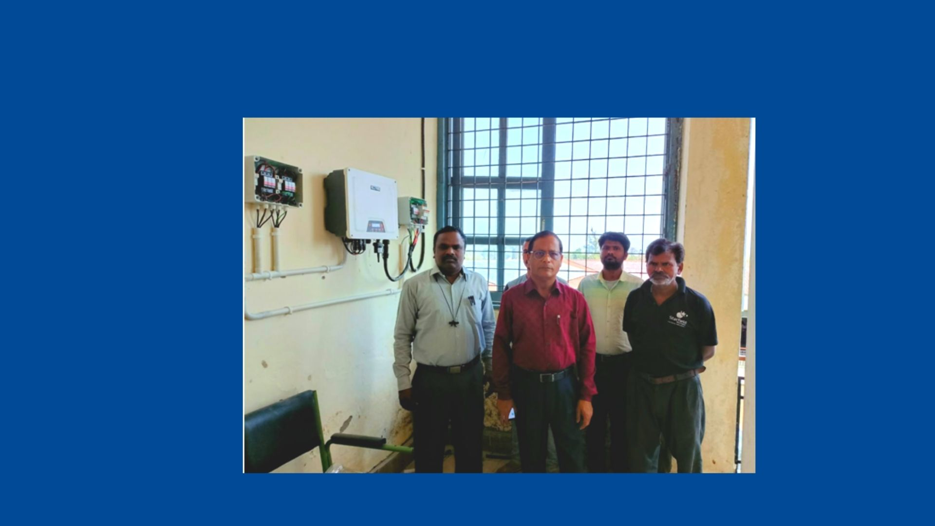

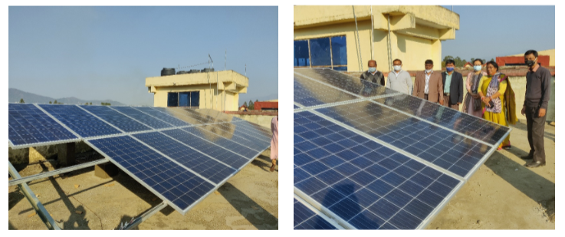

Photo: Some pictures of Solar panel installation