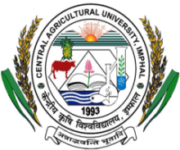
CENTRAL AGRICULTURAL UNIVERSITY
LAMPHELPAT, IMPHAL 795 004 (MANIPUR), INDIA
Website: cau.ac.in
E-mail : di.office @ yahoo.com

No. CAU/DI/ 270/18-19/ Dated: 21.04.2022

NOTICE INVITING EXPRESSION OF INTEREST

Central Agricultural University, Imphal invites sealed Expression of Interest (EOI) in two separate bids (Technical & Financial) from the bonafide suppliers/vendors/dealers for empanelment with the University for supply of Books and other information sources (Print, Non-print and Electronic) to the 13 constituent college libraries. EOI complete in all respects must be submitted in sealed envelope separately for both technical and financial bid should be delivered by Registered/speed post addressed to the Director of Instruction, Central Agricultural University, Lamphelpat, Imphal – 795004 on or before 18th May, 2022 upto 2.00 P.M. Sealed envelope should be marked on the top as ‘Empanelment with the University for supply of Books to the Central Agricultural University, Imphal’. EOI will be opened on the same day at 3.00 P.M. in presence of bidder (s) if possible. The details of the same are available on Central Agricultural University website : www.cau.ac.in.

Sd/-

Director of Instruction

