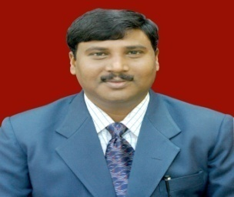

Dr. Daya Ram started his higher education B.Sc. (Ag) at Purvanchal University Jaunpur. He completed his M.Sc. (Ag) and Ph.D. degree in Extension Education in 1999 and 2005 from BHU Varanasi. He started his professional career in teaching in 2004 and has been serving as Assistant Professor (Extension Education) College of Agriculture Central Agricultural University, Iroisemba Imphal West- 795 004 (Manipur ) since 2006. He has successfully guided 18 PG students and one students Ph.D. He has two research projects (one as PI and one as Co PI). He has 80 research publications 20 popular articles/short communications, 6 manuals, 10 book chapters and 1 book. He is also a member of 8 Professional Bodies. He has been awarded with 2 Best Paper Presentation award, and 3 Young Scientist awards.

