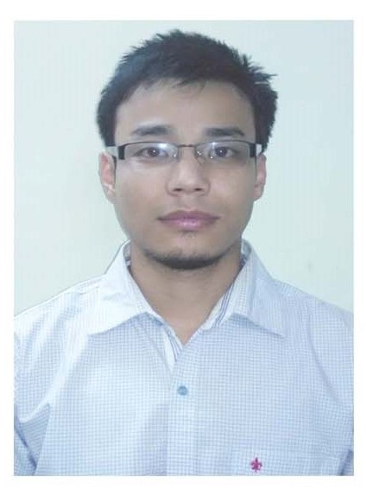

About Dr.Sanjenbam Dayananda Singh
Dr. Sanjenbam Dayananda Singh was born in the year 1988 at the Mayanglanging Village, Imphal west district, Manipur. He completed his graduation in Agriculture from Hemwati Nandan Bahuguna Garhwal University, Garhwal in the year 2010. He obtained his M.Sc. and Ph.D. programme in Agronomy discipline from College of Post graduate studies, Central Agricultural University, Imphal during 2012 and 2016, respectively. After completion of his Ph.D, he served as senior research fellow under Mission on Integrated Development of Horticulture project at ICAR-RC for NEH region, Mizoram centre during October, 2016 to October, 2017 and Mapping and Introgression of Weed Competitiveness in NEH genotypes project at Central Agricultural University, Imphal during October, 2017 to January, 2018. He has been working as Assistant Agronomist under All India Coordinated Research Project on Maize at College of Agriculture, Central Agricultural University, Imphal since January, 2018. He has developed various management technologies specially for the maize crop and also involved in teaching Agronomy courses. He has authored several research papers and review articles in Internationals and National Journals of repute. He is a member of Maize Technology Association of India and also served as speciality editor of Journal of Current Opinion on Crop science.

