Weekly activities of the IDP- NAHEP under Central Agricultural University, Imphal (27th August to 2nd September, 2021)

- A one day online skill development training on “Spices Entrepreneurship Development with Special reference to Export” under NAHEP-IDP was conducted at CAEPHT, Ranipool on 28th August,2021. The resource persons was Mr. M.S. Ramalingam, Deputy Director, Spices Board, Indian Cardamom Research Institute, Regional Research Station, Tadong, Gangtok, Sikkim. A total of 220 students participated in the two days workshop.
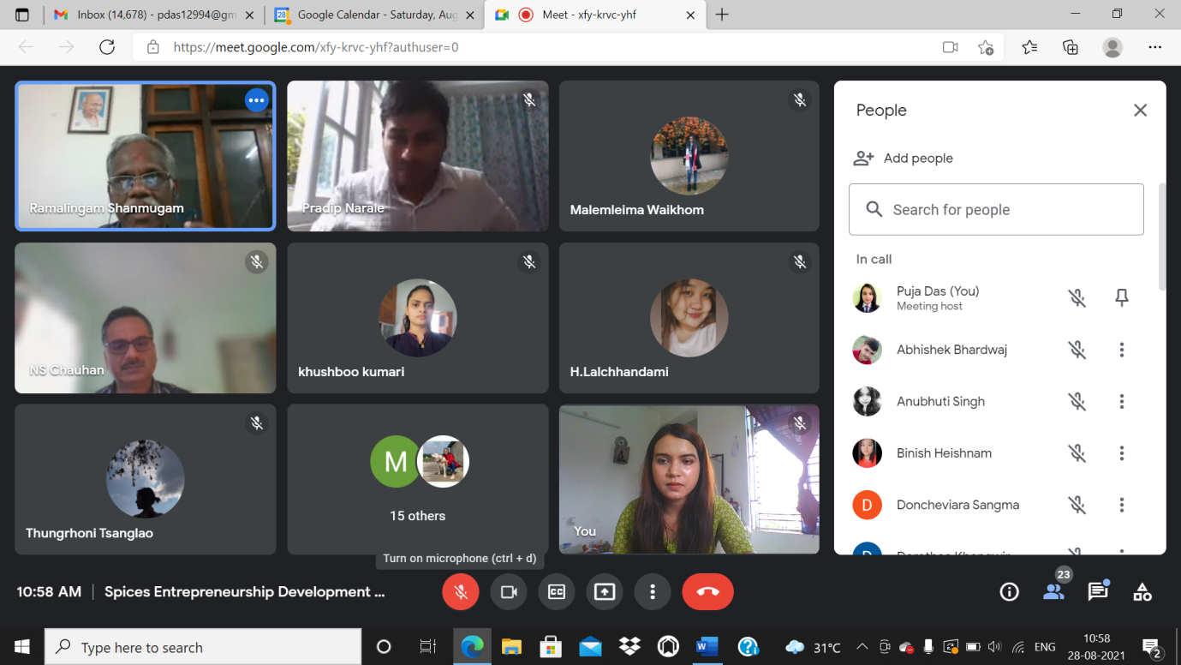
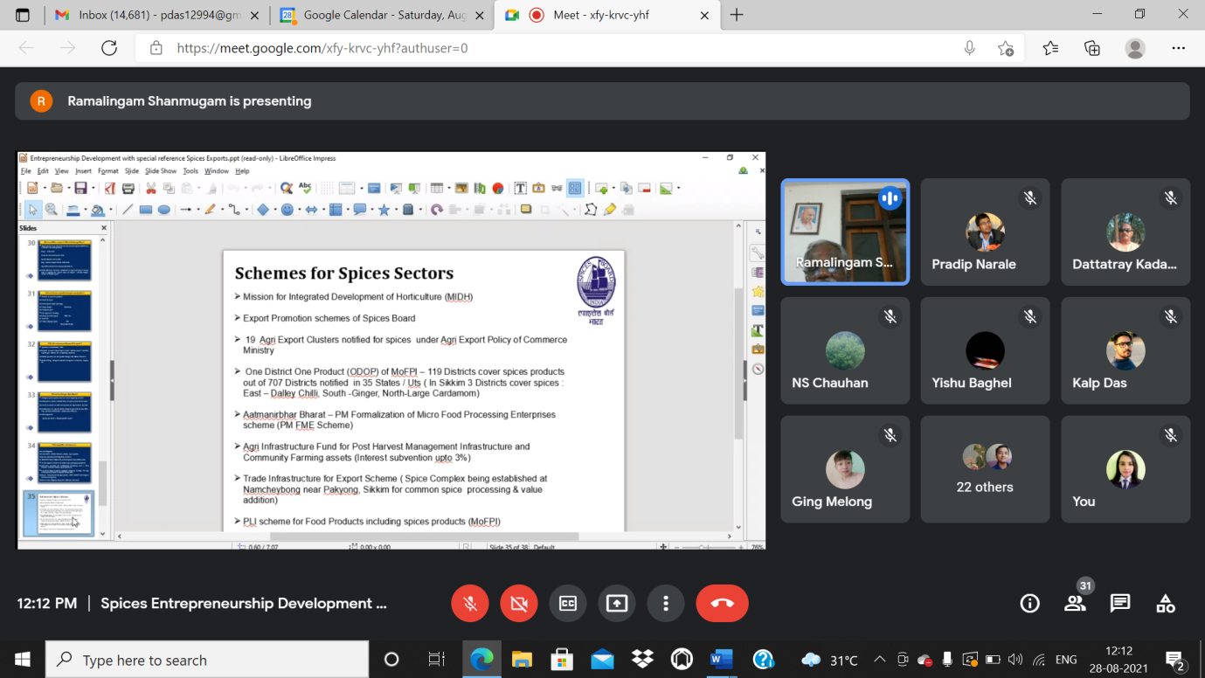
Photo: A one day online skill development training on “Spices Entrepreneurship Development with Special reference to Export” at CAEPHT, Ranipool

- A three days national webinar on "Seed production of vegetable crops: A lucrative venture" under NAHEP-IDP was stated at College of Horticulture & Forestry, Pasighat from 26th to 28th August, 2021. The resource persons were Dr. Nakul Gupta Scientist, ICAR-IIVR, Varanasi, UP; Dr. Madhavi Reddy K., Principal Scientist, ICAR-IIHR, Hessaraghatta, Bengaluru; Dr. Chander prakash, principal Scientist, ICAR-IARI, Himachal Pradesh; Dr. Yvonne Angel Lyngdoh, Scientist, ICAR-IARI, New delhi; Mr. Jogendra Singh, Scientist, ICAR-IARI, New Delhi; Dr. A.V.V. Koundinya, Scientist, ICAR-CTCRI, Thiruvananthapuram, Kerala; Dr. N.S. Nagegowda ACTO, ICAR-IIHR, Hessaraghatta, Bengaluru and Dr. Veluru Bhargav, Assistant Professor, MTTC & VTC, CHF, CAU, Pasighat. A total of 213 students participated in the three days national webinar.
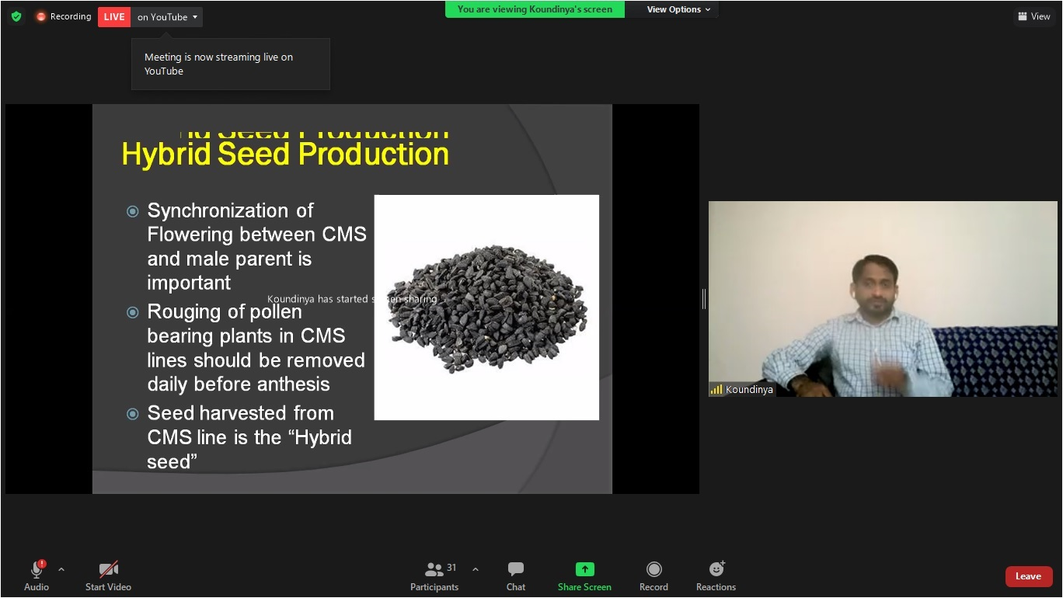 | 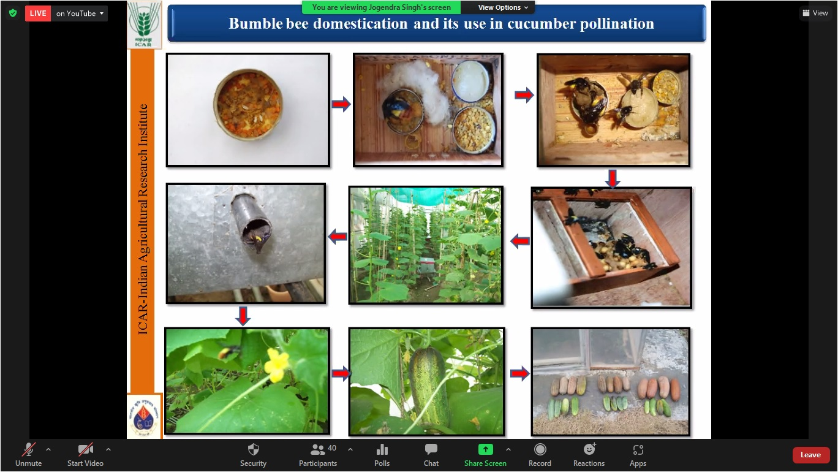
Photo: A three days national webinar on "Seed production of vegetable crops: A lucrative venture" at College of Horticulture & Forestry, Pasighat.

- The online class of Communication Skills and Personality Development under IDP NAHEP, CAU, Imphal was conducted by Language Instructor College of Agriculture, Imphal on 1st September, 2021 for Basic Level attended by 45 students.
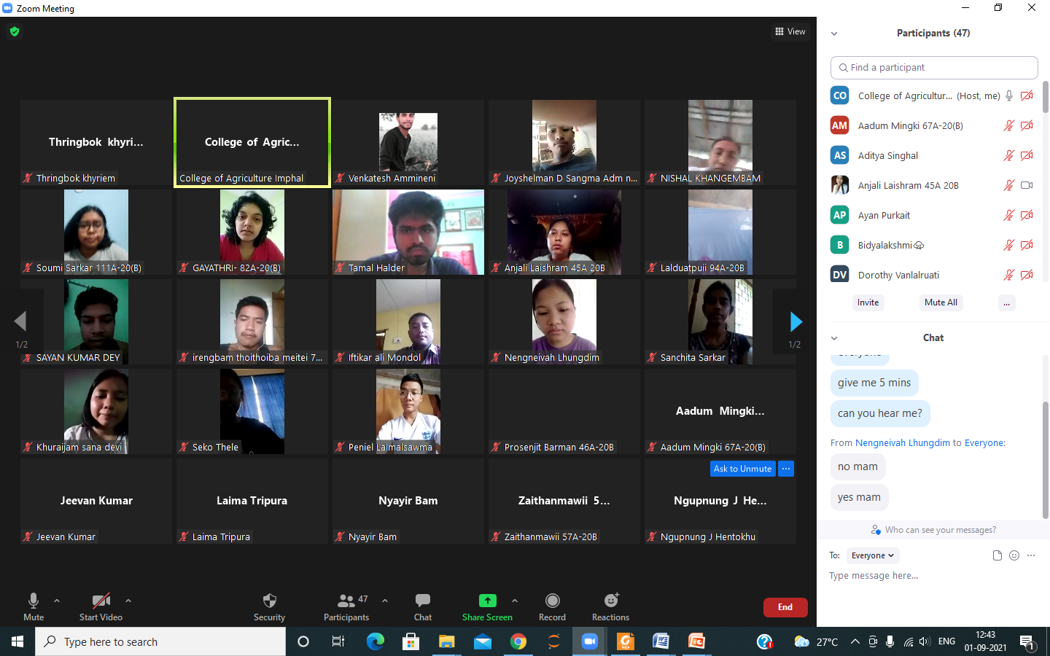
Photo: The Online class of communication skills and personality development by the Language Instructor at College of Agriculture, Imphal.

- The online class of Communication Skills and Personality Development under IDP NAHEP, CAU was conducted through Google classroom on 2nd September, 2021 at CVSc & AH, Mizoram for topic “English speaking practice” attended by 27 students.

