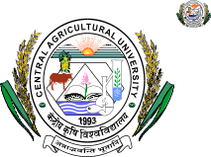
CENTRAL AGRICULTURAL UNIVERSITY
IMPHAL 795 004 (MANIPUR), INDIA
Phone No. +91 0385 2412945 (O)
Fax : +91 0385 2412945
Website: cau.ac.in
E-mail :di.office @ yahoo.com
Dr. S. Basanta Singh
Director of Instruction
________________________________________________________________________________________
No.CAU/DI-NAHEP/277/IDP-Report/2020. Imphal, the 9th September, 2021
To,
Dr. P. Ramasundaram,
National Coordinator (IDP),
National Agricultural Higher Education Project (NAHEP),
Indian Council of Agricultural Research,
R.No. 514 Krishi Anusandhan Bhavan- II,
New Delhi- 110012
Email: ncidp.nahep@icar.gov.in

Sub: Weekly activities of the IDP- NAHEP under Central Agricultural University (3rd to 9th September, 2021), Imphal.

Sir,
With reference to the above cited subject, I am submitting herewith the weekly activities of the IDP- NAHEP under Central Agricultural University, Imphal for your kind information and further necessary action, please.

Yours Sincerely,

(S. Basanta Singh)
Director of Instruction & PI
IDP-NAHEP, CAU, Imphal

Weekly activities of the IDP- NAHEP under Central Agricultural University, Imphal (3rd to 9th September, 2021)

- On 3rd September, 2021, a National Training on ‘Entrepreneurship Opportunities in Milk Sector’ was held at 6:30 pm on Zoom as the platform. Dr Vivek Ksheersagar, Managing Director, Pune Zilla Sahakari Dudh Utpadak Samgh, Pune was the resource person and the recorded attendance of the training program was 28. The event was hosted by College of Veterinary Sciences & Animal husbandry, Selesih, Aizawl.
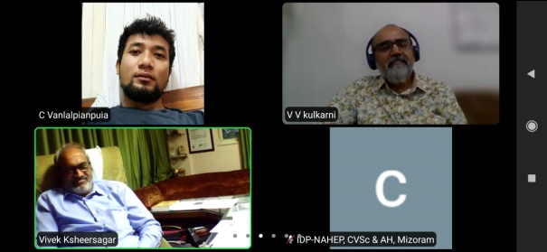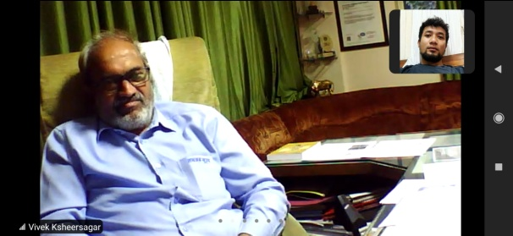
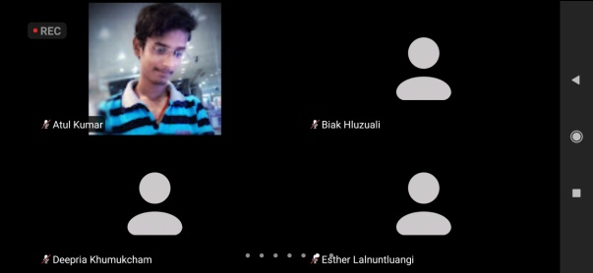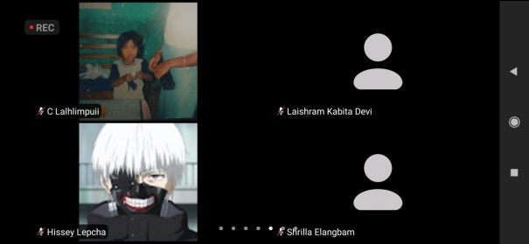
Photo: National Training on ‘Entrepreneurship Opportunities in Milk Sector’
- On 8th September 2021, College of Veterinary Sciences & Animal husbandry, Selesih, Aizawl conducted an online language class for 1st year BVSc & AH students at 1:00 pm using Google Classroom as the platform. The total number of attendees recorded was 46. The topic of the day was ‘How to improve your vocabulary’. The main aim of the topic was focussed on how to increase vocabulary. The 3R method on how to improve vocabulary was discussed in length, along with the steps involved. This method consists of three R- Read, Record and Review. The steps involved in 3R were also explained.
SOCIAL SAFEGUARD

Sl. No. | Activities | Target | Achieved | ST |  | SC |  | Gen |  | Total
 |  |  |  | M | F | M | F | M | F | Total
- Capacity Building for Students

1 | National Training | B.V.Sc& A.H., M.V.Sc., Ph.D and Alumni. | 3. 09. 2021  “Entrepreneurship Opportunities in Milk Sector” | 9 | 15 | 0 | 2 | 1 | 1 | 28
2 | Communication Skill | Online Language Class for B.V.Sc & A.H. students | 8. 09. 2021  “How to improve you vocabulary” | 13 | 23 | 1 | 3 | 2 | 4 | 46

- A two-day National Seminar on Agribusiness Potential in North Eastern Region with Special Reference to Tripura was held from 8th to 9th September 2021 at the College of Fisheries, Lembucherra, Agartala.

- Three days training webinar entitled “Seed Production of vegetable crops: A lucrative venture” held on 26th and 28th August 2021 at College of Horticulture and Forestry, Pasighat, Arunachal Pradesh. Dr. Nakul Gupta, Scientist, Division of Crop Improvement, ICAR- IIVR, Varanasi, U.P; Dr. Yvonne Angel Lyngdoh, Scientist, Division of Vegetable Science, ICAR-IARI, Pusa Campus, New Delhi; Dr. Chander Prakash, Head and Principal Scientist, ICAR-IARI Regional Station Katrain (Kullu Valley), Himachal Pradesh; Dr. Madhavi Reddy K., Principal Scientist & I/c Head, Division of Vegetable Crops, ICAR, IIHR, Hessaraghatta, Bangaluru, Mr. Jogendra Singh, Scientist, Division of Vegetable Science, ICAR-IARI, Pusa Campus, New Delhi; and Dr. A.V.V. Koundinya, Scientist, ICAR-CTCRI, Thiruvananthapuram, Kerala were the resource persons for the event. Topics covered in the event are Prospects and challenges of seed production of vegetable crops, Seed production of legume crops, Seed production of cole crops and root crops, Seed production of solanaceous crops, Seed production of cucurbitaceous crops, Seed production of bulb crops and Processing and seed certification
- Another three days online webinar entitled “Mushroom Production: An Opportunity for Self Employment” from 06th to 08th September, 2021 at College of Horticulture & Forestry, Pasighat. Dr. Daya Ram (Professor), Dr. Rajendra Prasad Central Agricultural University, Pusa (Samastipur), Bihar; Dr. Santosh Kumar (Asstt. Professor), Bihar Agricultural University, Sabour (Bhagalpur), Bihar; Dr. S. K. Biswash (Professor), Chandra Shekhar Azad University of Agriculture & Technology, Kanpur, Uttar Pradesh; Dr. C. S. Azad (Asstt. Professor), Bihar Agricultural University, Sabour (Bhagalpur), Bihar; Dr. Ram Chandra (Professor), Banaras Hindu University, Varanasi, Uttar Pradesh; and Dr. Sudarshan Maurya, (Principal Scientist), Indian Vegetable Research Institute, Varanasi, Uttar Pradesh were the key speakers at the event.
SOCIAL SAFEGUARD
Sl. No. | Activities | Target | Achieved | ST | SC | Gen | OBC
Capacity building for students
1. | Three days training webinar on“Mushroom Production: An Opportunity for Self Employment ” held on 06th and 08th September , 2021; 10:00 a.m to 12:30 p.m & 2:00 p.m to 4:00 p.m) | 250 | 207 | 20 | 31 | 75 | 81
1. | Three days training webinar on “Seed Production of vegetable crops: A lucrative venture” held on 26th and 28th August, 2021; 10:00 a.m to 12:30 p.m & 2:00 p.m to 4:00 p.m) | 250 | 213 | 30 | 18 | 165 | 0

- Work for setting up of audio system at Virtual classroom, Academic Block I of College of Agriculture, Iroisemba, CAU, Imphal was completed.
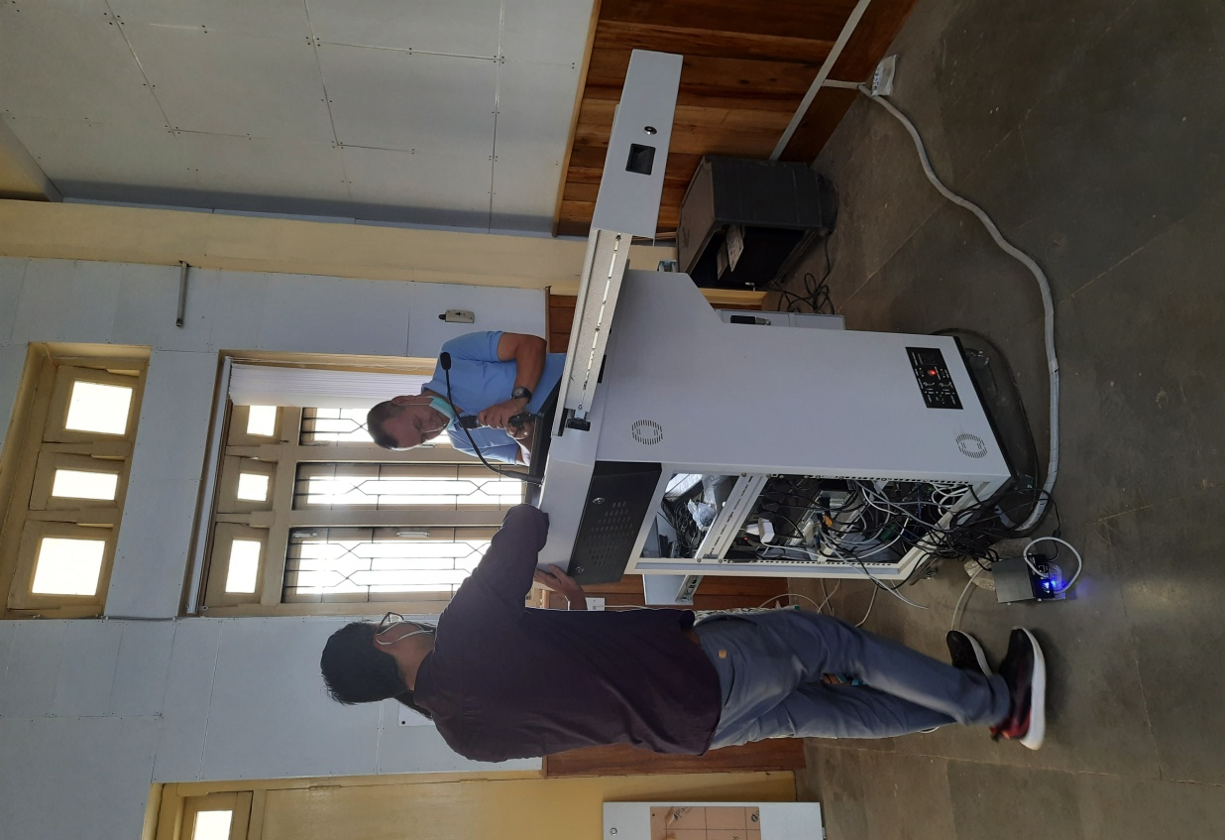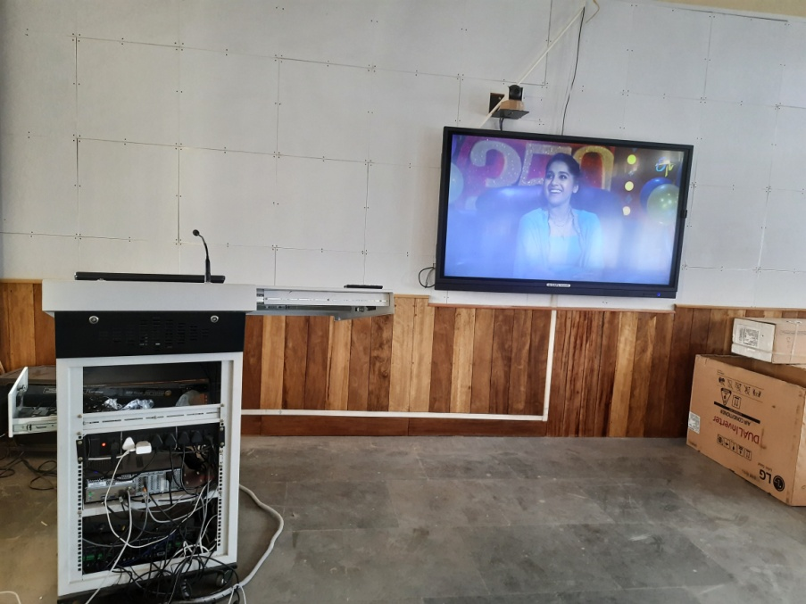
Photo: Setting up of audio system at Virtual classroom, Academic Block I of College of Agriculture, Iroisemba

