Weekly activities of the IDP- NAHEP under Central Agricultural University, Imphal (20th to 26th August, 2021)
- A one day National training on “Gender Analysis Skills for Agriculture and Allied Sectors” was organized through ZOOM platform at College of Veterinary Science & Animal Husbandry, Mizoram by resource person Dr Veenita Kumari, Deputy Director, Gender Studies, MANAGE, Hyderabad under NAHEP-IDP on 23rd August, 2021. A total of 67 students participated in the training program.

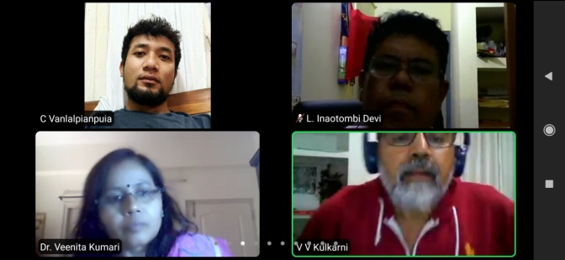 | 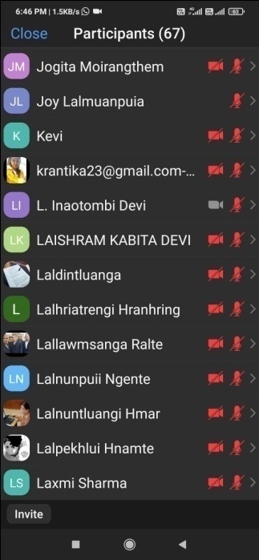

Photo: A one day National training on “Gender Analysis Skills for Agriculture and Allied Sectors” at College of Veterinary Science & Animal Husbandry, Mizoram

- The six days online workshop on “Enhancing computational capabilities of students: A beginners level course on Python” under IDP NAHEP started on 21st August, 2021 and will continue till 27th August, 2021 at College of Agriculture, Imphal. Dr. K. B. Vedamurthy, Assistant Professor, KVAFSU, Dairy Science College, Bengaluru was the resource person. A total of 43 students participated in the online workshop.

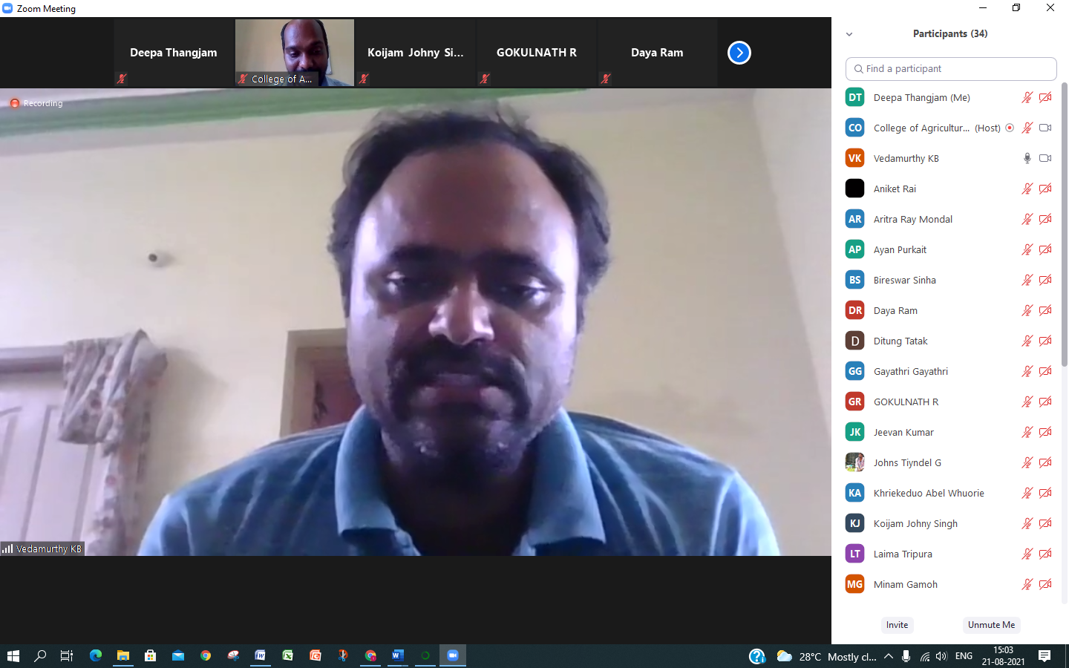 | 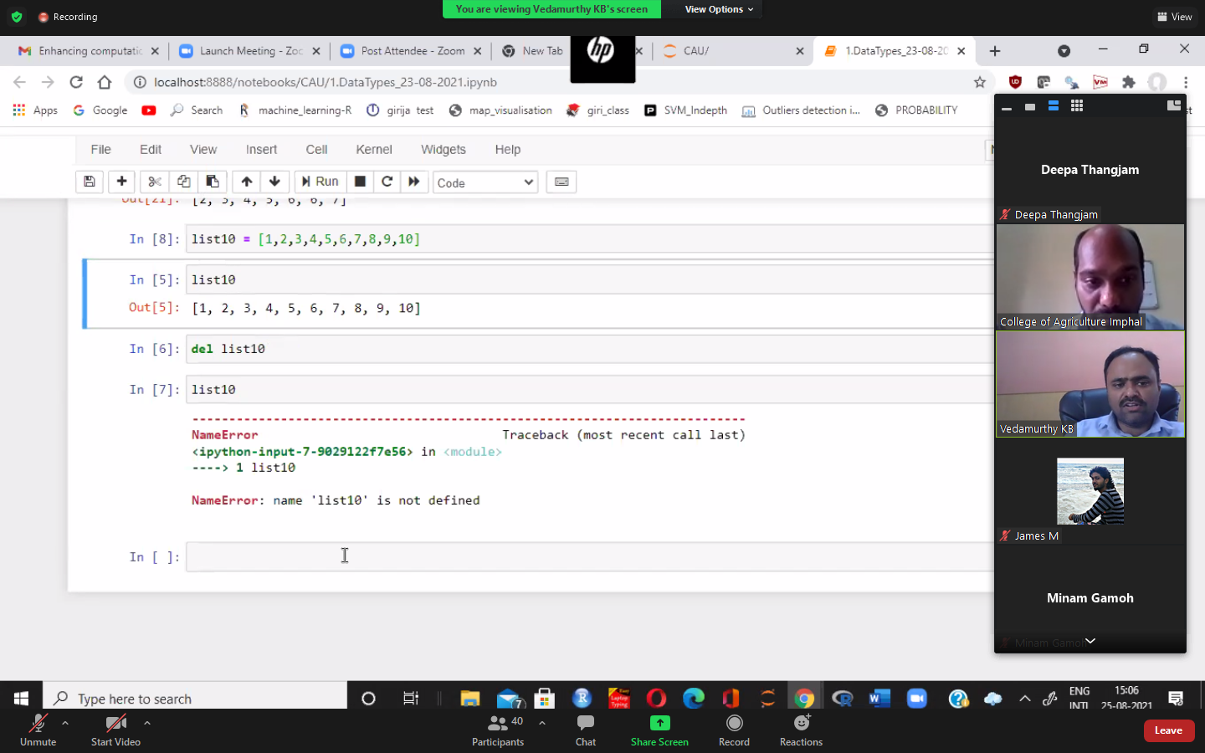
Photo: Glimpse of online workshop on “Enhancing computational capabilities of students: A beginners level course on Python” at College of Agriculture, Imphal.

- Under Environmental Sustainity Plan of IDP NAHEP, CAU, Imphal, planting of sapling in campuses of College of Agriculture, Imphal was conducted for the purpose of beautifying the campus and making it green.
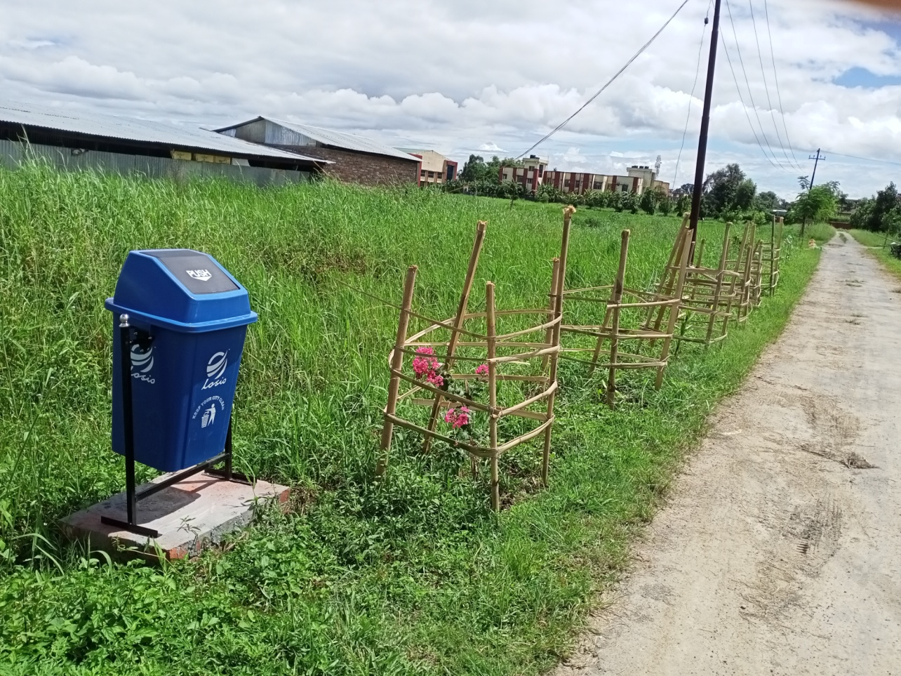 | 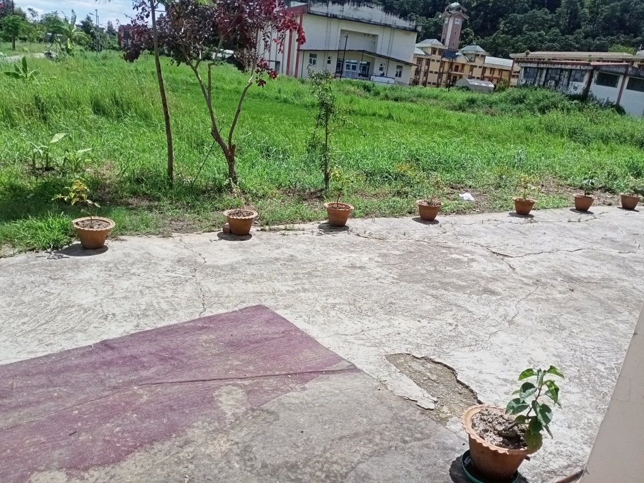
Photo: Glimpse of planting of saplings at College of Agriculture, Imphal.

- The online class of Communication Skills and Personality Development under IDP NAHEP, CAU was conducted through Google classroom on 25th August, 2021 at CVSc & AH, Mizoram for topic “Word stress” attended by 17 students.

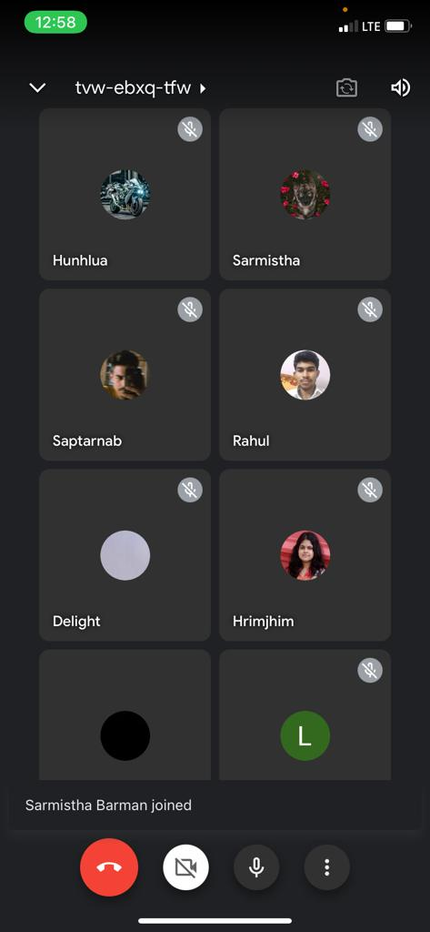
Photo: Screenshot for online class of Communication Skills and Personality Development under IDP NAHEP, CAU at CVSc & AH, Mizoram.

